Contents

1. Introduction 2

2. Computer Graphics Primer 2

2.1 The Rendering pipeline 2

2.2 Transformations 3

Projections 4

2.3 Color 5

2.4 Lighting and Shading 5

2.5 Texture Mapping 5

3. Fundamental Concepts 6

3.1 Visualization Pipeline 6

3.2 Sources of Error 6

3.3 Data Domain 7

3.4 Coordinate Systems 7

3.5 Data Structures 7

3.5.1 Structured Grids 8

3.5.2 Unstructured Grids 8

3.5.3 Scattered Data and Triangulation 9

3.5.4 Differentiation on Grids 9

3.6 Interpolation 10

3.6.1 Local Interpolation 11

3.6.2 Global Interpolation 12

4. 1D and 2D Scalar Fields 13

4.1 Diagram Techniques 13

4.2 Isolines 14

4.3 Color Coding 16

4.4 Glyphs, Icons and others… 18

5. Vector Fields 18

5.1 Arrows and Glyphs 19

5.2 Characteristic Lines in Vector Fields 19

5.3 Particle Tracing 20

5.4 Line Integral Convolution 20

6. 3D Scalar Fields 21

6.1 Volume Visualization 21

6.2 Slicing of Volume Data 22

6.3 Classification 22

6.4 Indirect Volume Rendering 22

6.4.1 Opaque Cubes 22

6.4.2 Marching Cubes 23

6.4.3 Marching Tetrahedra 24

6.4.4 Surfaces from Contours 25

6.5 Direct Volume Rendering 25

6.5.1 Volume Rendering Equation 26

6.5.2 Direct Volume Rendering 26

Raycasting 27

Texture-based Volume Rendering 27

6.5.3 (Other) Compositing Schemes 28

6.5.4 Classification 29

Segmentation 29

Volumetric Shading 30

Outlook 30

# Introduction

Visualization is a method of computing. It transforms the symbolic into the geometric, enabling researchers to observe their simulations and computations. Visualization offers a method for seeing the unseen

* Definitions and goals
  + Insight and analysis
    - Extract information content
    - Make coherences visible that are not apparent
    - Analyze data by means of visual representation
  + Communication
    - Allow the non-expert to understand
    - Guide the expert into the right direction
  + Steering
    - Interactively control and drive your application
    - Accelerate the understanding of phenomena

# Computer Graphics Primer

## A diagram of a building Description automatically generatedThe Rendering pipeline

* Key Graphics Areas
  + Modeling
    - Mathematical specification of shape and appearance properties of objects
    - Primitives: Points, lines, curves, surfaces, …
    - Attributes: color, texture maps, lighting properties, …
    - Geometric transformations
  + Rendering
    - Creation of shaded images from 3D computer models given
    - 2D images from 3D scenes
* Geometry representation
  + Points (= vertices) w.r.t. a known coordinate system
    - Vertices are used for modeling polygons (objects)
  + Arbitrary (=willkürlich) polygons and surfaces are represented as triangles
    - Triangles, Triangle Strips, Triangle Fans -used to build meshes -> Meshes form objects
  + Attributes are associated with vertices
    - Color, material, surface normal vectors, ...
    - Used to calculate final appearance (pixel color)
* Vertex ordering is counter-clockwise
* Rasterization
  + The framebuffer is the intermediate memory space storing the accumulated pixel values

## A diagram of a diagram Description automatically generatedA diagram of a diagram of a fish Description automatically generatedA diagram of different types of objects Description automatically generatedA diagram of a process Description automatically generatedTransformations

* 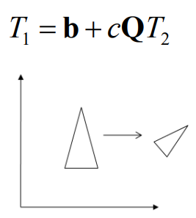Linear Transformations
  + Two geometric objects, T1 and T2: T1 und T2 kongruent wenn sie sich umkehrbar lassen bzw. vom einen in den anderen transformieren lassen
* Basic 2D Transformations
  + Matrix multiplication: • Scaling • Rotation
  + 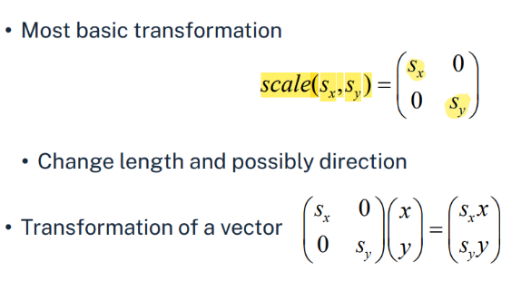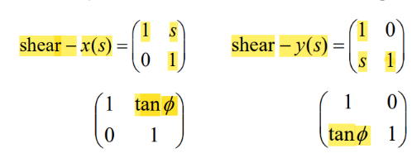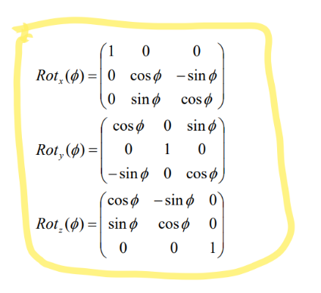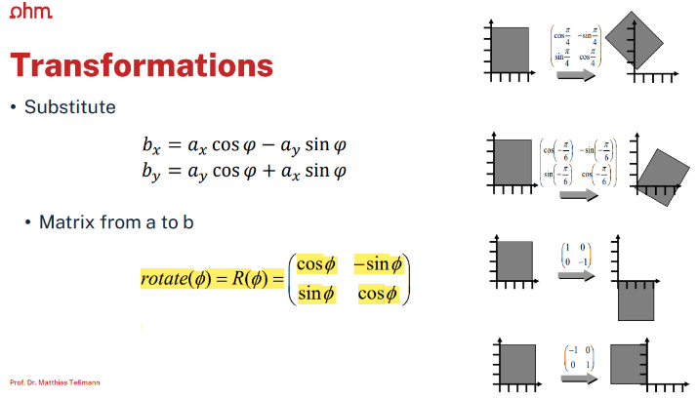Different operation of transformations on: • Locations (points) • Displacement vectors • Normal vectors (surface normals)
  + Shear
  + Rotation
  + Composition of 2D Transformations
    - Matrix multiplications are associative (R S) T = R (S T) => (RS)v = Mv
    - Applied from the right side first! Here: first apply S, then R
    - The order of transformations does matter
  + A matrix is orthogonal if
    - orthogonal => inverse == transponierte
* 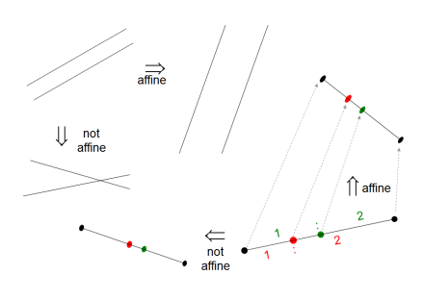Affine Transformations
  + Linear Transformation and Translation
  + Characterization
    - Maps lines to lines
    - 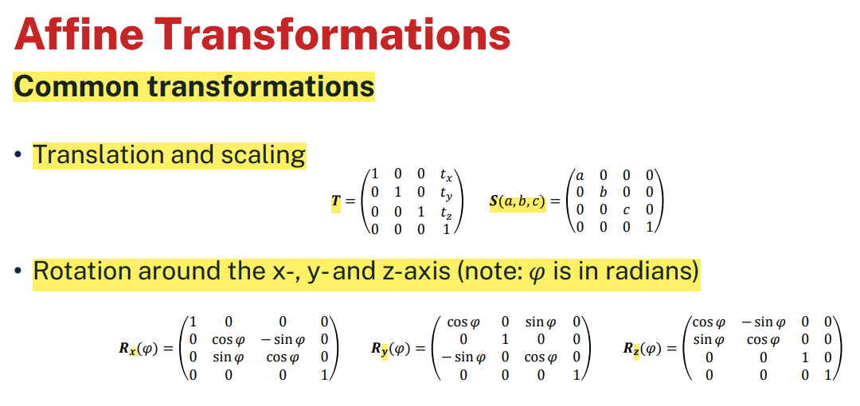Parallel lines will be mapped to parallel lines
    - 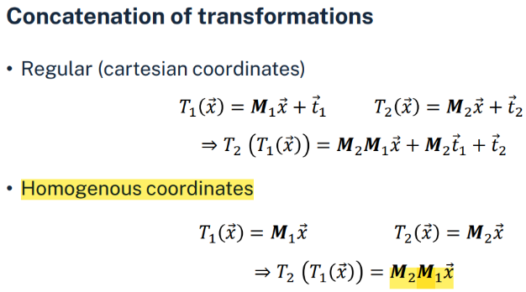Division rations will be kept
    - 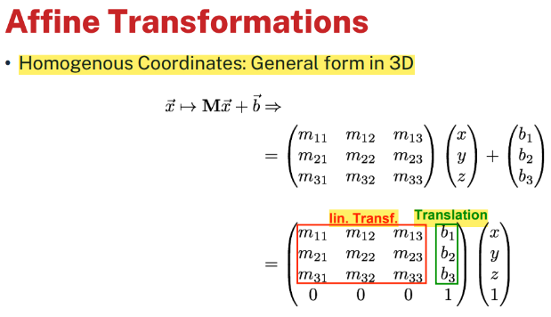Angles are not preserved
  + You cannot "translate" direction vectors!
    - Homogenous coordinates
      * 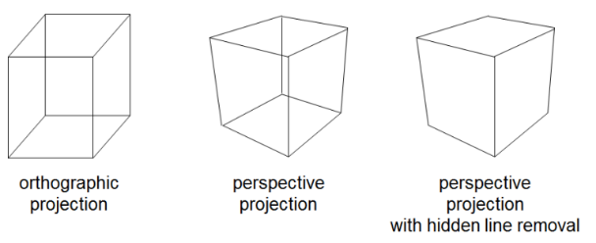Add third / fourth (2d/3d) coordinate w (1 for point, 0 for vector). 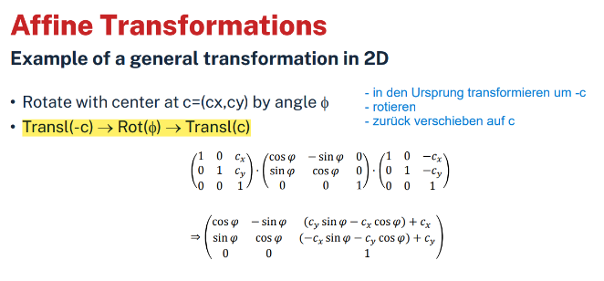

## Projections

* Orthographic projection: parallel lines map to parallel lines
* 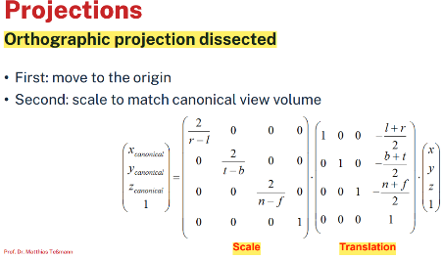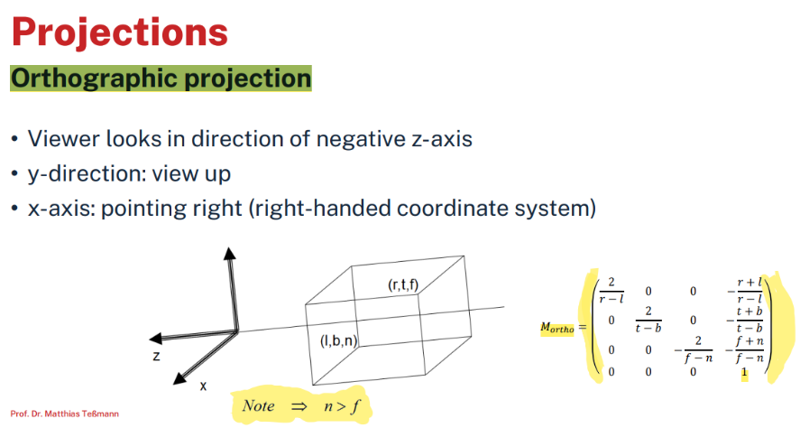Perspective projection: have 1, 2 or 3 vanishing points
* Projections transform the scene into the canonical view volume
* Orthographic projection
* 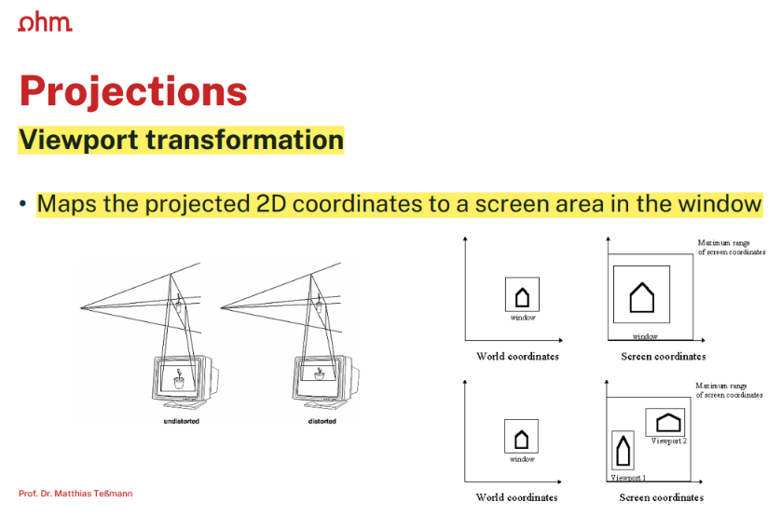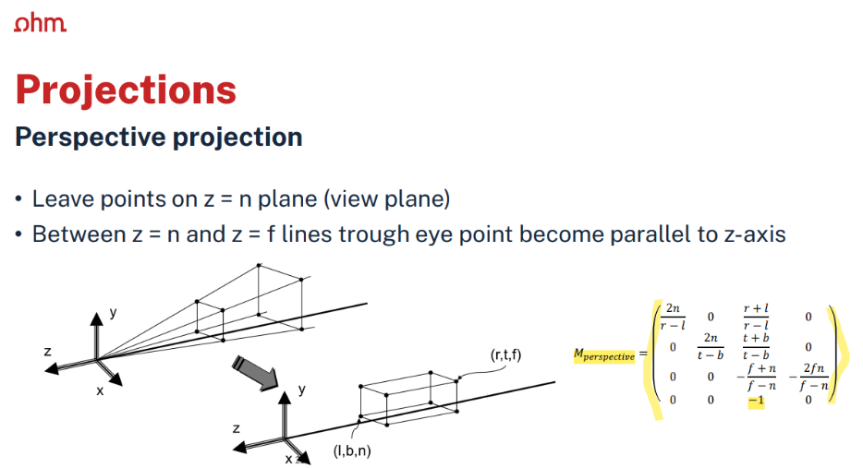Normalizing transform
  + Regions close to observer enlarged, distant regions shrink

## A red triangle with black lines and yellow text Description automatically generatedColor

* RGB color model
  + Black = (0,0,0), White = (1,1,1)
  + Additive (colors added to a black background)
* HSV color model
  + Hue, saturation and value primaries
  + Hue (H) range [0 o, 360 o ]
  + Value (V) range [0, 1]
  + Saturation (S) range [0, 1]
  + Hue ist Winkel, Value ist y-Achse, Saturation ist x-Achse
* Other color models
  + CMY: Cyan, magenta and yellow
    - primaries -used usually on hardcopy devices (printers)
    - Subtractive (white background!)
  + CMYK. Addition of K-channel for black (saving ink)

## Lighting and Shading

* Lighting
  + Attempt to create a realistic image
    - Simulate lighting of the surfaces in the scene
    - Fundamentally: simulation of physics and optics
  + Ambient light • Indirect light from surrounding
  + Diffuse light • Reflection from rough surfaces
  + Specular light • Reflection from "glossy" but not perfectly mirroring surfaces

## A diagram of a wood floor Description automatically generatedTexture Mapping

* Textures
  + Functions or pixel-based images containing reflectance information
  + Attach "images" to polygons to achieve highly detailed surface at low cost
  + Assign reflectance information to pixels by lookup
    - Texture: typically 2D pixel image (may be 1D or 3D)
    - Determines appearance of a surface
    - Texel: Pixel in a texture
    - Requires procedure to map the texture onto the surface (mapping)

# Fundamental Concepts

## A diagram of a flowchart Description automatically generatedVisualization Pipeline

* 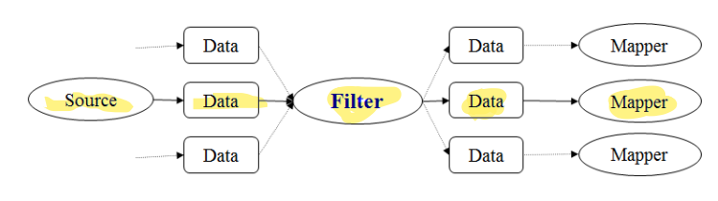Filter: transform data into data
  + Data format conversion
  + Clipping, cropping, de-noising
  + Slicing, resampling
  + Interpolation, approximation
  + 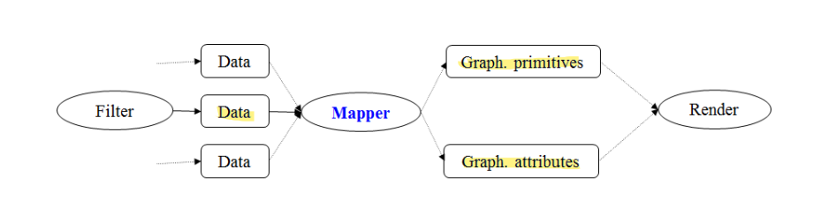Classification, segmentation
* Mapper: transform data into graphical primitives
  + Scalar field to iso-surface
  + 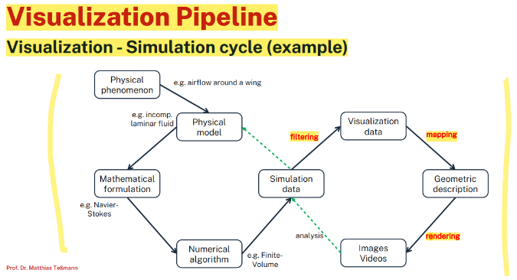Vector field to glyphs …
* 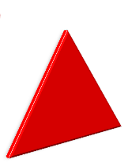Rendering
  + Geometry / images / volumes
  + Lighting, shading
  + Texturing

## 3.2 Sources of Error

* Data acquisition
  + Sampling: Sufficient (spatial) sampling of the data to get what we need?
  + Quantization: Conversion of "real" data to representation with enough precision to discriminate the relevant features?
* Filtering
  + Are we retaining / removing the "important / non-relevant" structures?
* Selecting the "right" variable
* Functional model for resampling
  + Introduced information by interpolation and approximation?
* Mapping
  + Appropriate choice of graphical primitives?3
* Rendering
  + Need for interactive rendering
  + Consider limitations of the underlying display technology
  + Carefully add "realism": The most realistic image is not necessarily the most informative one

## A screenshot of a cell Description automatically generatedA diagram of visualization based on mapping Description automatically generated3.3 Data Domain

* Discrete representations
  + Given data: discrete in space and/or time
  + Consist of samples → generate grids/meshes consisting of cells
* Classification of visualization techniques according to
  + 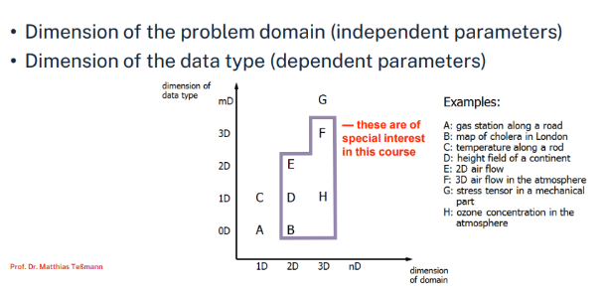Dimension of the domain: 0D (means unstructured points); 1D, 2D, 3D, nD
  + Type of the data: Scalar, vector, tensor, multi modal
  + Grid type
    - Uniform cartesian, structured, curvilinear
    - Unstructured, point sets (scattered data)
* Influence types
  + Point influence: Only influence on the point itself
  + Local influence: Only influence within a certain region around the point
  + Global influence: Each sample might influence any other point within the domain

## A diagram of a mathematical equation Description automatically generatedA diagram of a mathematical equation Description automatically generated3.4 Coordinate Systems

* 2D coordinate systems & Polar coordinates
* 3D coordinate systems
* P-space ↔ C-space
  + Transformation, where P-space: physical space <--> C-space: corresponding uniform computer representation

## 3.5 Data Structures

* Scattered data: Arbitrarily(=willkürlich) distributed points with no connectivity in between
* 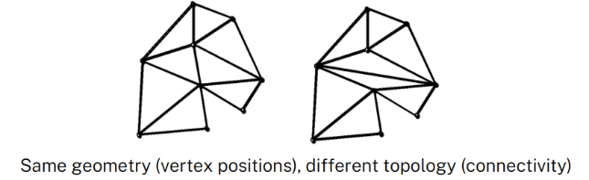Otherwise: Data is composed of cells bounded by grid lines
* Geometry: Specifies the position of the data
* Topology: Specifies the structure (connectivity) of the data
  + Properties of geometric shapes that remain unchanged even under distortion
  + 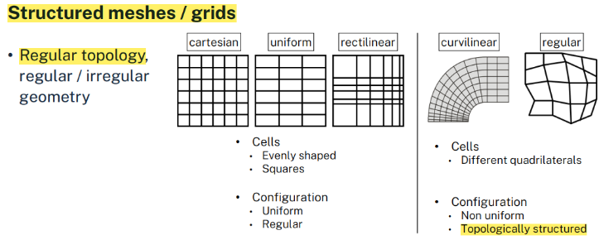Shapes that can be transformed into each other without tearing or introducing new connections are topologically equivalent
* 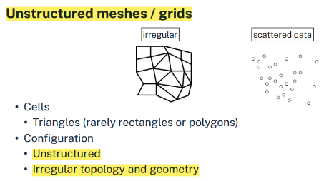Structured meshes / grids
  + Regular topology, regular / irregular geometry
* Unstructured meshes / grids

### 3.5.1 Structured Grids

* Characteristics of structured grids
  + Simple computation & May require more elements or badly shaped elements to cover the underlying domain
  + Topology: Implicitly given by an n-vector of dimensions
  + Geometry: Explicitly given by an array of points
  + Every interior point has the same number of neighbors
* Cartesian or equidistant grids
  + Number of points: Nx * Ny * Nz
  + Number of cells: (Nx – 1)* (Ny – 1) * (Nz – 1)
  + Global index allows for linear storage scheme
* Uniform grids
  + Like cartesian grids
  + Equal cells, but with different resolution in at least one dimension (dx <> dy (<> dz))
* Impact of cell spacing: Affects almost all calculations, algroithms and visualization aspects. E.g. interpolation, differentiation…
* Structured grids stored in 3D array
* Accessed by indexing
* Topology information implicitly given -> Direct access to adjacent elements

### 3.5.2 Unstructured Grids

* Characteristics of unstructured grids
  + Significantly more difficult and complex -> But much more flexible
  + No implicit topological (connectivity) information given -> Grid points + connectivity must be explicitly stored
  + Dedicated data structures needed
  + Often composed of triangles or tetrahedra -> Requires triangulation or tetrahedrization
* 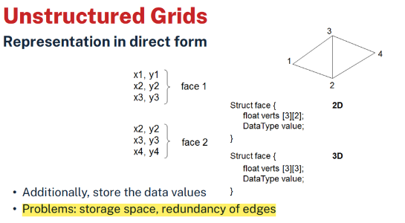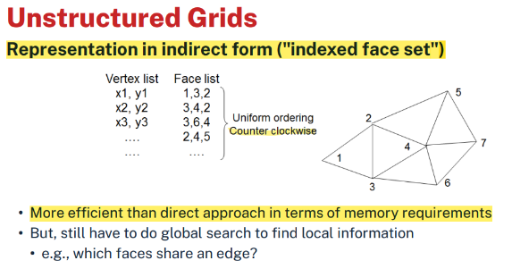Components
  + Dimension
  + Number of vertices
  + Number of cells
  + Vertex list
  + Cell list
* 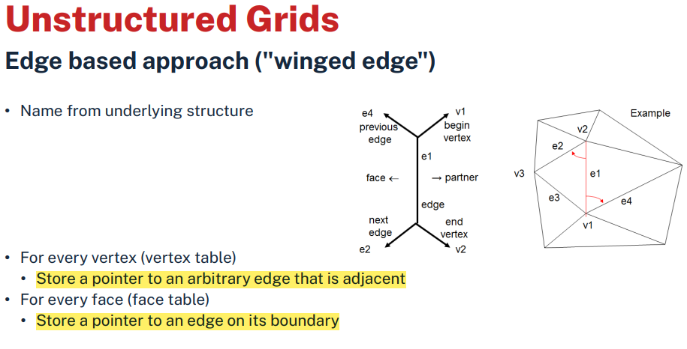Edge based approach ("winged edge")
  + Answers the following queries
    - Faces sharing an edge
    - Faces sharing a vertex
    - Walk around: faces, vertices (like a fan)
  + Implicit assumption: Every edge has at most 2 faces which meet at the edge
  + Advantages: Memory efficient and fast traversal

### 3.5.3 Scattered Data and Triangulation

* Scattered points
  + 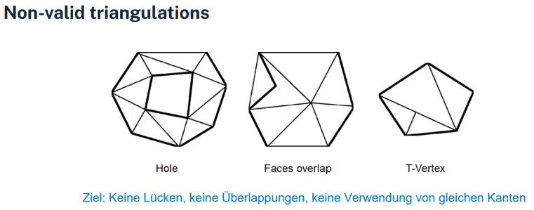Problem: create grid from scattered points
  + Given: Number of vertices, Vertex list
* Triangulation
  + Given information
    - Data points: (x0, y0), (x1, y1), ..., (xN-1, yN-1)
    - Data values: f0, f1, ..., fN-1
  + 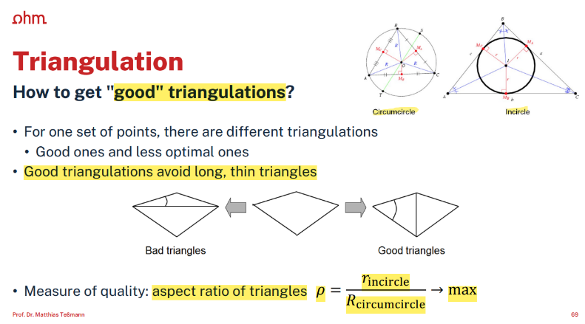"Neighborhood information" is required (topology)
    - Task: Find triangular mesh with given scattered data points as vertices
  + As measure for "good" triangulation of the data points, consider the "roundness" of triangles
  + 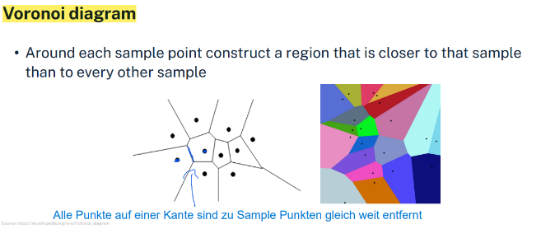Voronoi diagram

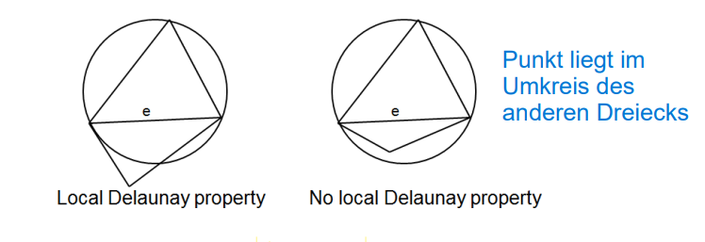

* + Delaunay triangulation
    - The vertices of the Voronoi diagram as circumcenters of triangles (Umkreise)
    - Schnittpunkte der Kreise verbinden
    - Delaunay triangulation is the geometric dual of the Voronoi diagram
    - Maximizes the smallest angle and the aspect ratio of triangles
    - Triangles fulfill the "local Delaunay property"
    - For each edge, the perimeter of the adjacent triangle does not contain the 'other' vertex

### A math equations on a white background Description automatically generated3.5.4 Differentiation on Grids

* We actually want to visualize continuous data
* Points of special interest
  + Locations where quantities change rapidly (high variation)
  + Changes are measured by derivatives (differentials)
* First approach
  + Approximate / interpolate (locally) by differentiable function and differentiate this function -> Ableitung
* Second approach
  + Replace differential by "finite differences"

1D non uniform grid

* 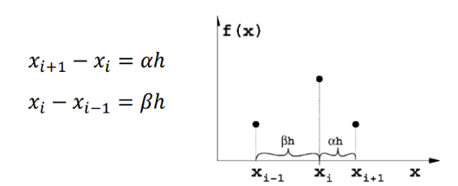1D uniform grids with grid size 𝒉 = ∆x (siehe Bild oben)
* 1D non-uniform grid
  + Forward or backward difference is the same as for uniform grids
    - Note: 𝒉 = ∆𝒙 is different in each direction, as spacing is non-uniform
  + 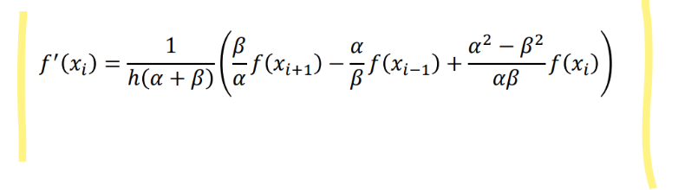Central difference needs to consider the different spacing
    - Siehe Taylor Polynom
    - final approximation of the derivative
* 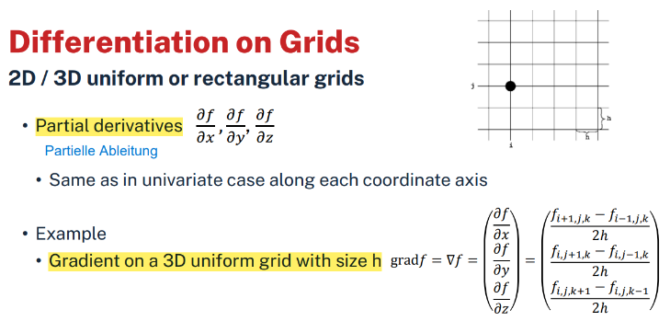2D / 3D uniform or rectangular grids
* Unstructured grids
  + Dilemma: There is no generalization of the difference quotient!
  + Solution 1: Interpolation / approximation with function to differentiate
    - Easiest case: linear interpolation in each cell leads to one gradient per cell
  + Solution 2: Resampling into structured grid
    - Interpolation introduces additional error

## A diagram of a graph Description automatically generatedA screenshot of a grid Description automatically generated3.6 Interpolation

* 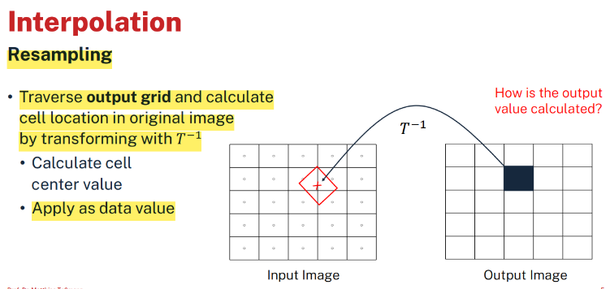Resampling
  + Traverse output grid and calculate cell location in original image by transforming with 𝑇−1
  + Calculate cell center value, Apply as data value
* Problem
  + (Image) function known only at discrete sampling points
  + Wir benötigen Function values in-between
* Interpolation. rekonstruieren der Funktion aus diskreten sampling points
  + Estimate values of unknown function in-between given sampling points
  + The ideal interpolation function for a continuous signal is sinc
  + Problem: sinc requires infinitely many samples for perfect interpolation
* Classification
  + Local interpolation methods (cell-wise): Use information stored in the neighbor nodes (vertices)!
  + Global interpolation methods: Use information of all vertices or a broader neighborhood

### 3.6.1 Local Interpolation

* Simple approximations
  + 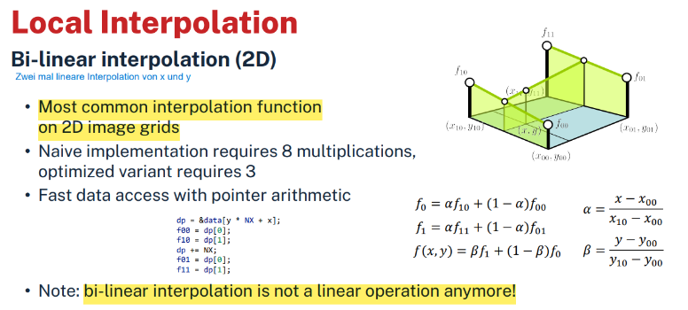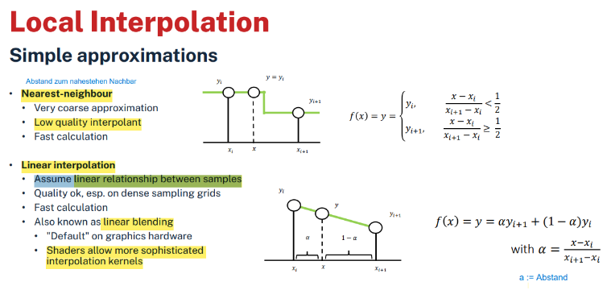Nearest-neighbour = Abstand zum nahestehen Nachbar
    - 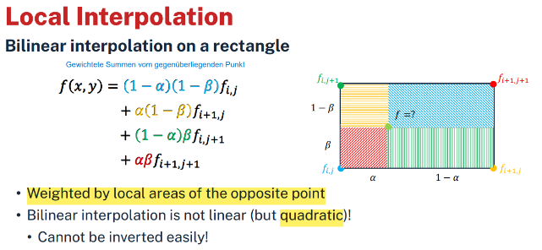Low quality interpolant
  + Linear interpolation
    - Assume linear relationship between samples
* Bi-linear interpolation (2D) -> Zwei mal lineare Interpolation von x und y
  + Most common interpolation function on 2D image grids
  + 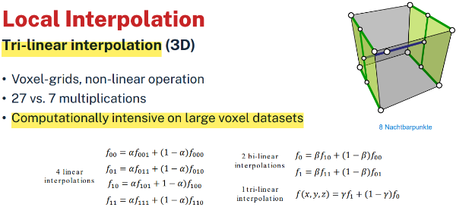Note: bi-linear interpolation is not a linear operation anymore!
* Tri-linear interpolation (3D)
  + Computationally intensive on large voxel datasets
* 3D-case on a 3D uniform grid
  + Trilinear interpolation of points (x,y,z)
  + Trilinear interpolation is not linear!
  + 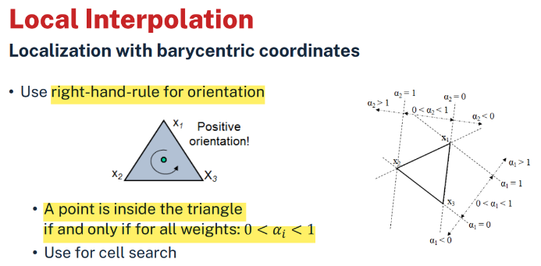Efficient evaluation (Horner)
    - 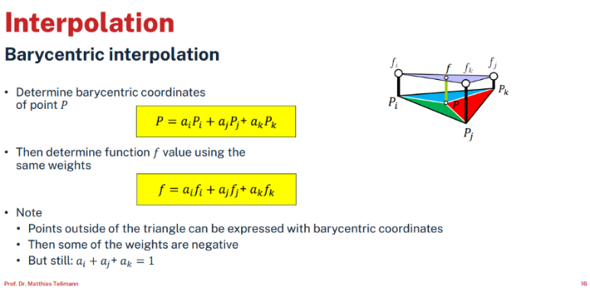Coefficients a, b, c, d, e, f, g from data at corner vertices
* Linear interpolation on a triangle
  + 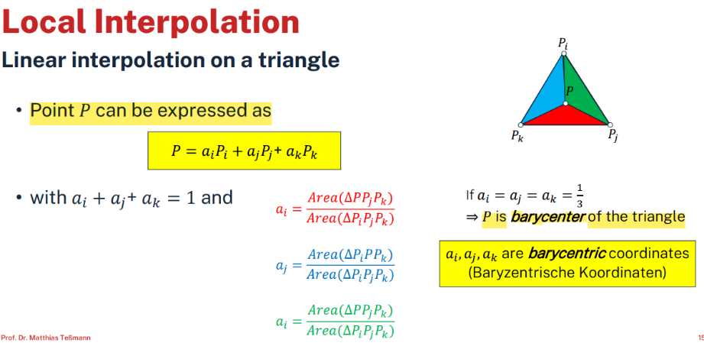Barycentric interpolation
  + 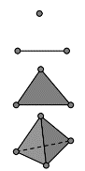Barycentric coordinates in multiple dimensions
    - 0D: point
    - 1D: line
    - 2D: triangle
    - 3D: tetrahedron
* Interpolation in a generic quadrilateral
  + 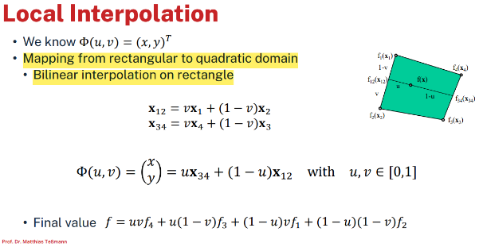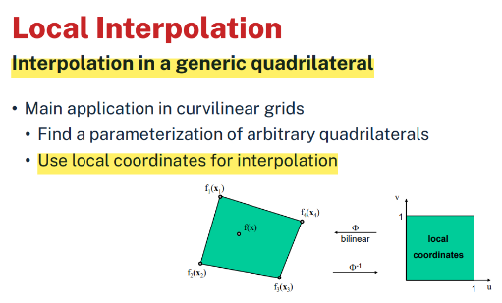Inverse Φ−1(𝑥, 𝑦) = (𝑢, 𝑣)T

### 3.6.2 Global Interpolation

* Interpolation aims to estimate function values based on samples
  + Linear interpolation: very simple + acceptable quality
  + Considers only local neighborhood
* To improve quality find a better approximation function

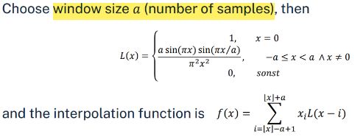

2: Lanczos Filter

* + Increases calculation cost (usually)
  + The right choice is often application dependent
* Might consider bigger neigborhood or all samples → global interpolation
* Lanczos Filter
  + sinc on a sliding window (neigborhood size)
* Splines
  + 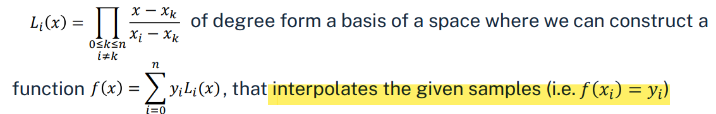In general, given 𝑛 + 1 samples {𝑥0, 𝑥1, … , 𝑥𝑛} and corresponding values {𝑦0, 𝑦1, … , 𝑦𝑛} , where 𝑥𝑖 ≠ 𝑥𝑘, if 𝑖 ≠ 𝑘 and 0 ≤ 𝑖, 𝑘 ≤ 𝑛 the set of polynomials
  + The polynomials are called Lagrange-Polynomials and there is a unique polynomial for any given set of points
  + Problems: For n+1 data points we get a polynomial of degree n
    - High degree polynomials lead to oscillation at the edges of intervals (Runge's phenomenon) –hence they are infeasible for interpolation of large data
  + Solution approach
    - Split the interval 𝑥0 ≤ 𝑥𝑛 into subintervals [𝑡0,𝑡1] , … , [𝑡𝑖,𝑡𝑖+1] , … [𝑡𝑛−1,𝑡𝑛]
    - Interpolate each subinterval with appropriate polynomial
    - Connect the individual segments → Spline
  + Continuity constraints at the interval borders depend on spline type
  + There exist different Spline types with different properties
    - Cardinal Splines, Catmull-Rom Splines, Bézier-Splines, B-Splines, …
* Catmull-Rom Interpolation
  + Compromise between "local linear" and "global B-Spline"
  + Properties
    - Spline passes through all control points (i.e. 𝑏𝑖 = 𝑥𝑖!)
    - Piecewise cubic, C1 -continous
* Hermite-Interpolation
  + Given 𝑃0, 𝑃𝑜 ′ , 𝑃1, 𝑃1 ′ , then there exists a unique cubic polynomial f
* Cardinal splines
  + Subset of Hermite curves
  + Calculate tangent points from control points

# 4. 1D and 2D Scalar Fields

* Data and Scales
  + Quantitative data: Numbers
  + Categorical data: Labels what numbers measure
  + Three types of categorical scales
    - Nominal scales: items Do not relate to one another in any particular way
      * zB Continents: the Americas, Asia, Europe, ... / Departments (e.g. sales, marketing and finance)
    - Ordinal scales: Consists of items with intrinsic order
      * 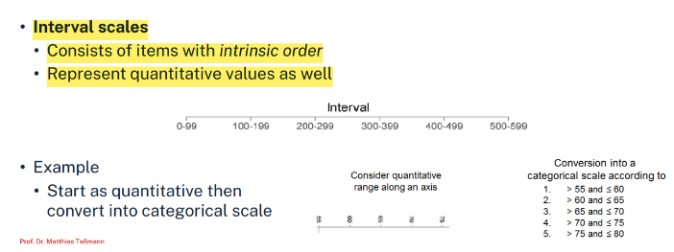"A, B and C" / "small, medium and large" / "poor, below average, average, above average and excellent"
    - Interval scales: Consists of items with intrinsic order
      * Represent quantitative values as well

## A line with a black arrow Description automatically generated4.1 Diagram Techniques

* 1D drawing / 2D drawing
* Example: Distance from reference location (e.g. Erlangen)
* 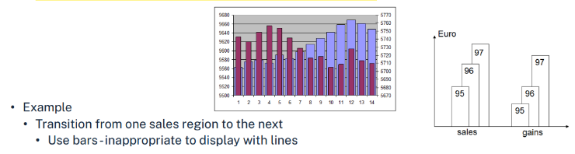Bar charts
  + Appropriate for nominal and ordinal scales
  + Individual items not related closely enough for link with lines
* 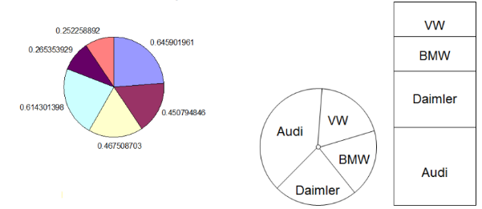Pie charts
  + Quantitative data that adds up to a (fixed?) number
* Histogram
  + 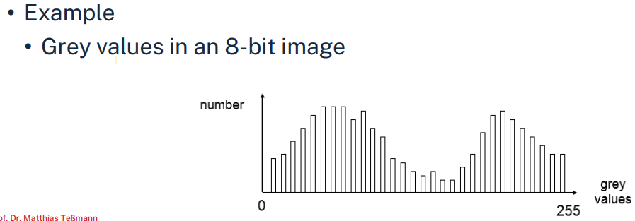Measure the frequency (number) of items 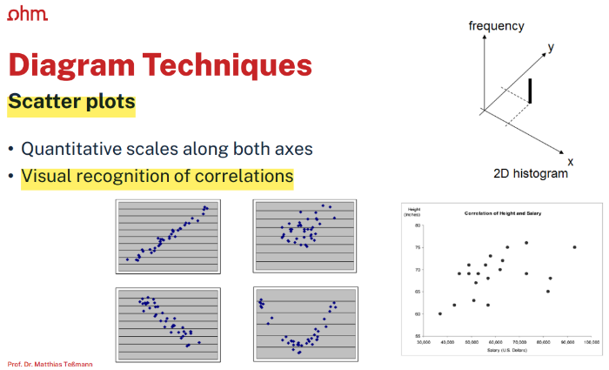
* Scatter plots
  + Quantitative scales along both axes
  + Visual recognition of correlations
* 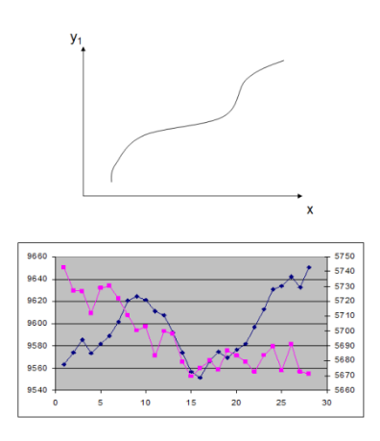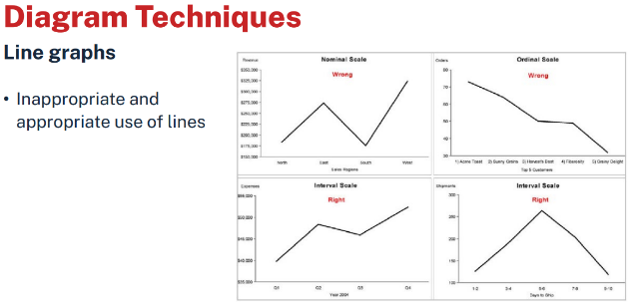Line graphs
  + Connection between points (interpolation!)
  + Appropriate for interval scale
    - Shows trend of patterns in the data
* Height Fields
  + 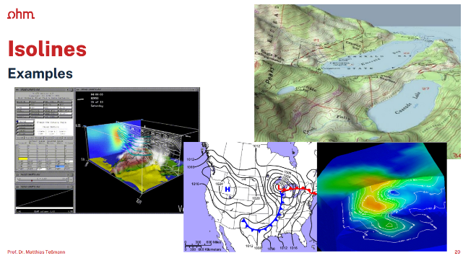Function plot for a 2D scalar field

## 4.2 Isolines

* Visualization of 2D scalar fields.
* Given a scalar function f: Ω → R and a scalar value c ∈ R
* The isoline / isocontour or contour line consist of points {(x, y) | f(x, y) = c}
  + Punkt -> Konstante bei Funktion für Punkt
* If f is differentiable and grad(f) ≠ 0, then isolines are curves
  + if grad(f) = 0 in some points, "isolines" may be single points or whole areas of the domain
  + Isolines are closed curves, or they get in and out of the domain. They do not terminate in the domain!
* Pixel by pixel contouring
  + Straightforward approach: Scanning all pixels for equivalence with iso-value
  + 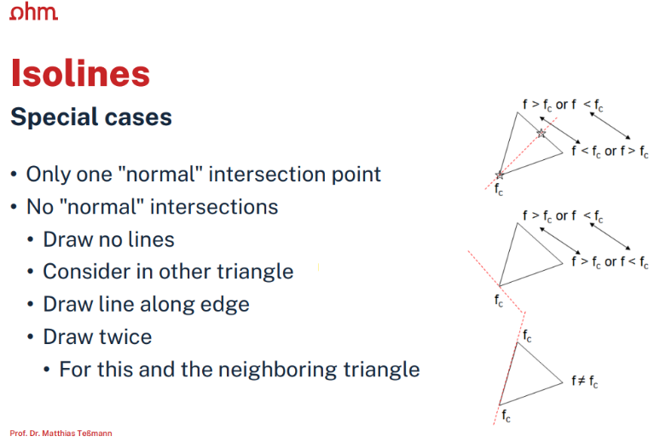Problems: Isoline missed if gradient of f is too large, produces no additional data, only visualization
* 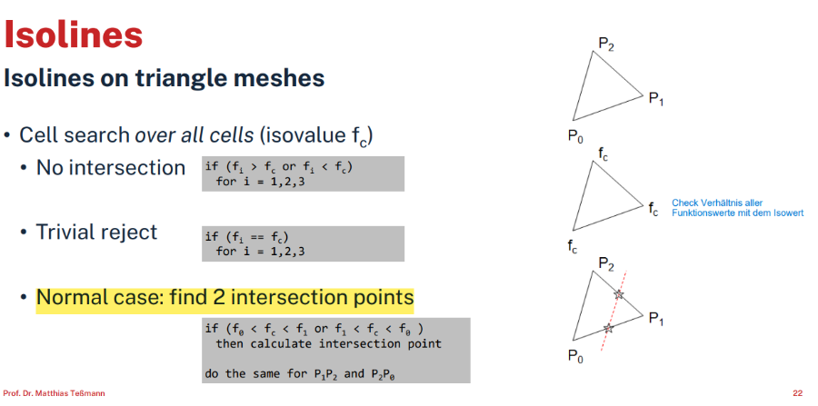Isolines on triangle meshes
* Calculate intersection points

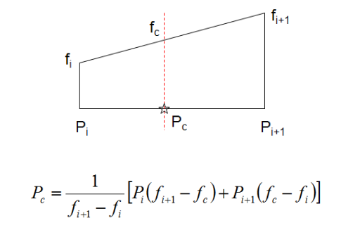

3: Calculate Intersection Points

* + Interpolate point from data value
* Rectilinear meshes
  + Representation of scalar function on a rectilinear grid
    - Scalar values are given at each vertex f ⟷ fij
    - 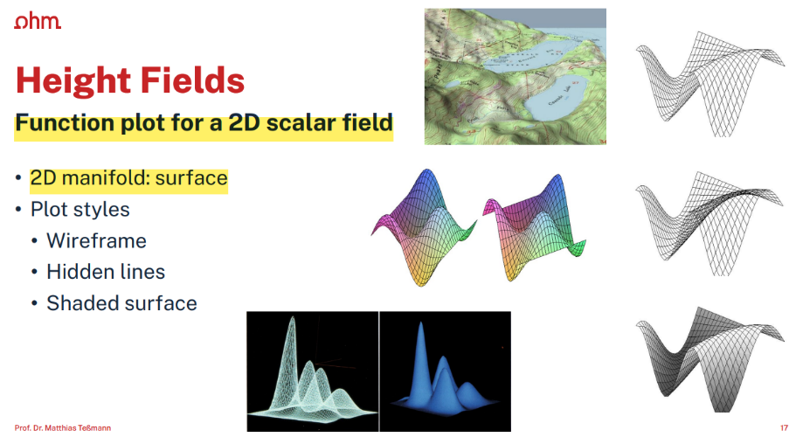Consider interpolation within cells (bilinear!)
  + 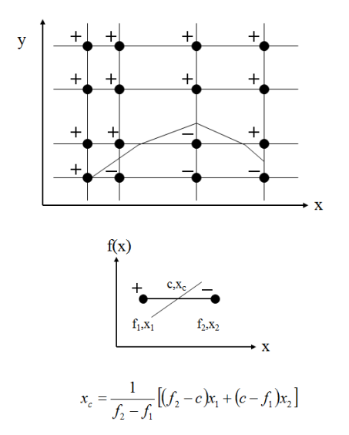Divide and conquer -"Marching Squares"
    - Consider cells independently of each other
* Marching Squares
  + Which cells will be intersected?
  + Initially mark all vertices with "+" or " -", depending on the condition fij ≥ c , fij < c
  + Isoline does not pass through cells which have the same sign at all four vertices
    - Only determine edges with different signs and find intersection by linear interpolation
  + There are 24 = 16 different intersection possibilities (combinations of signs)
    - 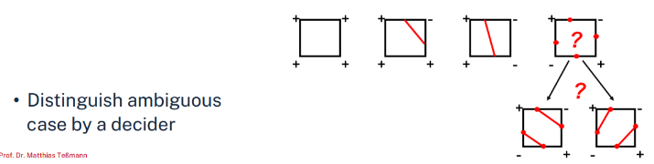Using symmetries, only 4 different cases remain (rotation, reflection)
    - Compute intersections between isoline and cell edge (linear interpolation)
  + 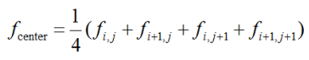Mid-point decider
    - 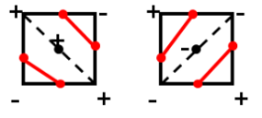Interpolate the function value at the center
    - If fcenter < c choose right case, otherwise left case
    - This is not always the correct solution!
  + Asymptotic decider
    - 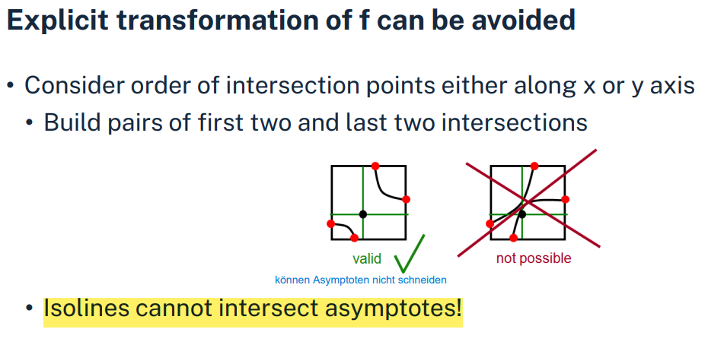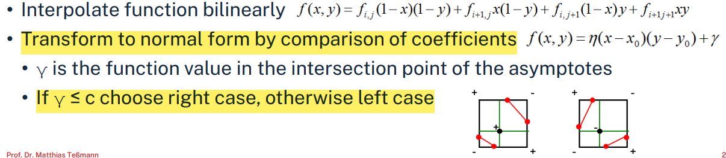We know that the true isolines within a cell are hyperbolas

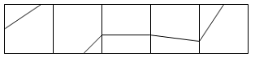

* Algorithms: Cell order approach for marching squares
  + Apply marching squares to each individual cell
  + Advantage: Simple approach
  + Disadvantage
    - Process every vertex and every edge twice
    - Output is just a collection of pieces of isolines which have to be post-processed to get (closed) isoline
* 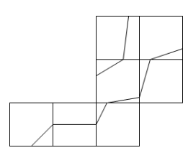Algorithms: Contour tracing approach
  + Start at a seed point of the isoline
    - Move to neighboring cell (into which the isoline enters)
    - Trace isoline until bounds of domain are reached or isoline is closed
  + Advantage: Polygons, Information about inclination
  + Disadvantage: Marking of processed cells (list of started contours)
    - Problem: how to find seed points efficiently?
    - Remove marker from traversed cells (unless 4 intersections!)
* Smoothing isolines
  + Evaluate gradient at vertices by central differences
  + 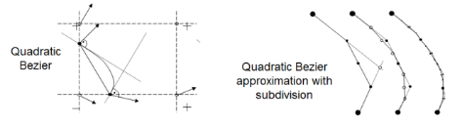Estimate tangents at intersection points by linear interpolation -Gradient is perpendicular to isoline!
  + Quadratic Bezier curve
* Summary
  + Smoothing by interpolation falsifies the contour
  + Multiple isolines: Line type (dashed, dotted, ... ), annotation, color

## A graph on a white background Description automatically generatedA screenshot of a computer Description automatically generatedA colorful map of different colors Description automatically generated4.3 Color Coding

* Linear transfer function for color coding
  + Specify color for fmin and fmax
    - (Rmin ,Gmin , Bmin) and (Rmax , Gmax , Bmax)
    - Linearly interpolate between them
  + 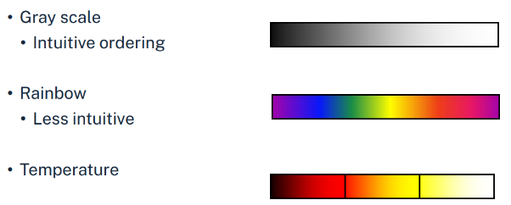In order to visualize (enhance / suppress) specific details, non-linear color lookup tables are needed
* Examples of different color tables -------------------------------->
* 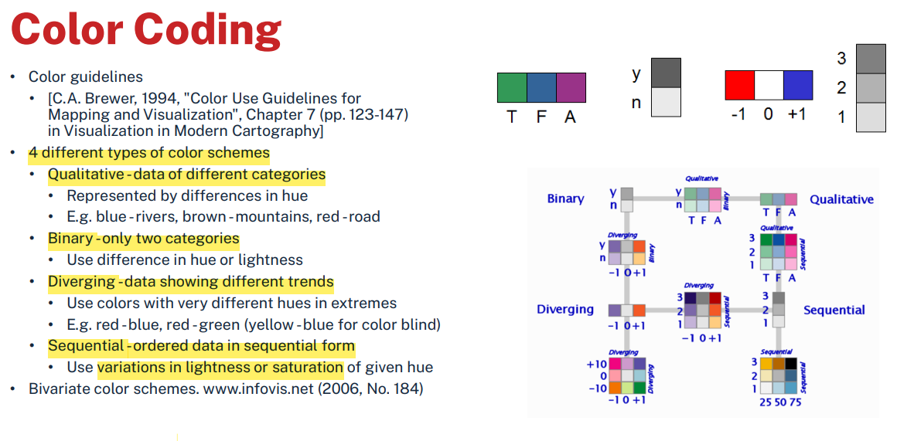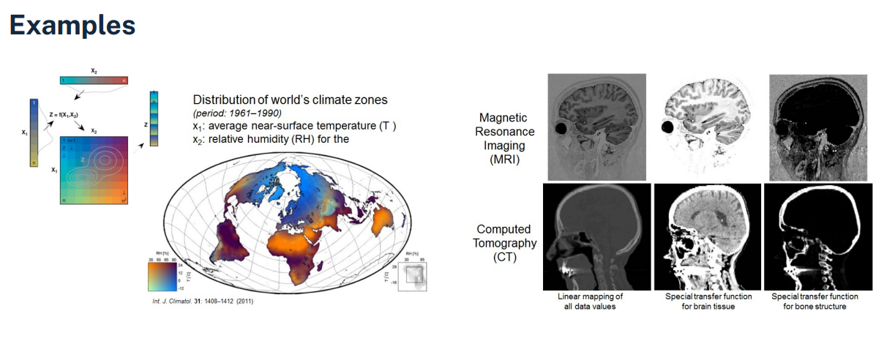Bivariate (2-dim) and trivariate (3-dim) color tables
  + Often, interactive specification of transfer function is needed to extract important features (which leads to nonlinear transfer functions), e.g. medical data
  + Not very useful as there is no intuitive ordering -> Colors hard to distinguish

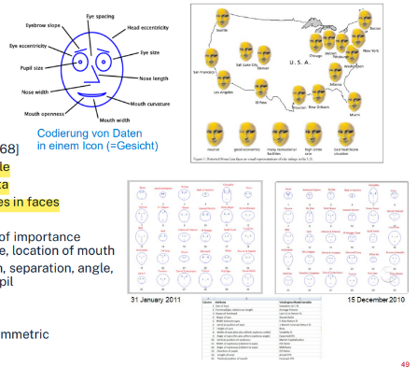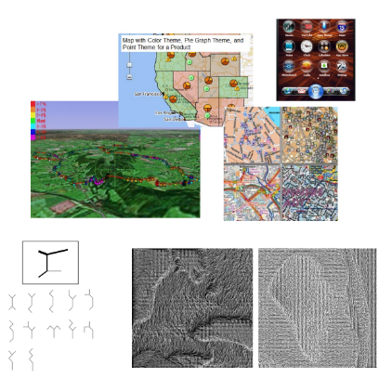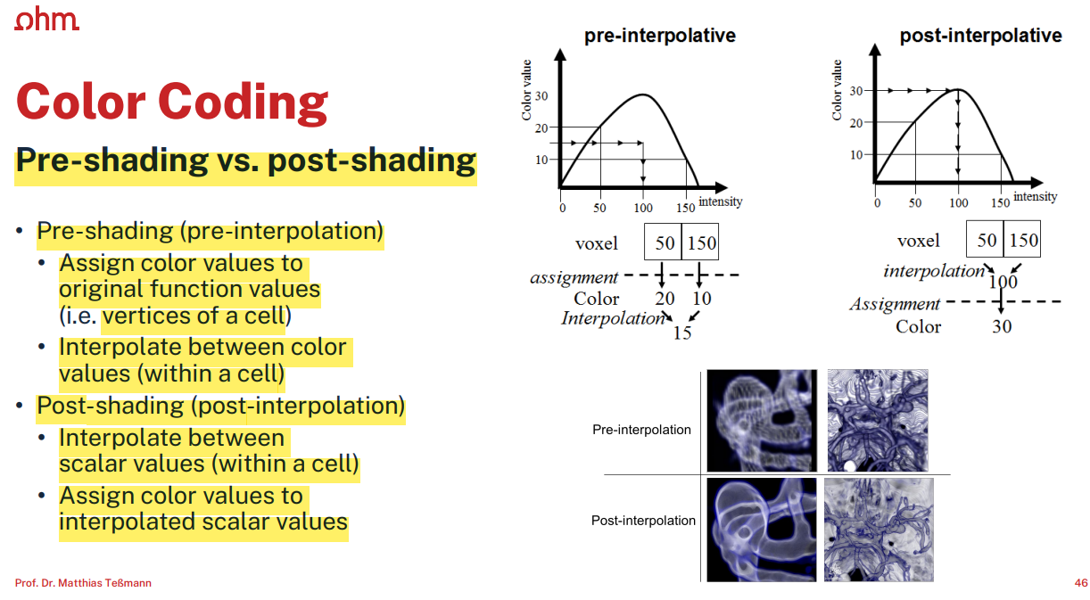

## 4.4 Glyphs, Icons and others…

* Glyphs and Icons
  + Should be easy to distinguish and combine
  + Coding of data via
    - Length, thickness, angle with vertical axis
  + multivariate Darstellung von Daten
    - More than one data value at each coordinate
  + Exploits human capability to recognize patterns/textures
  + Nützlich für zerstreute data representation

# 5. Vector Fields

* Problem: visualize a function like F: Ω→ℝ2, with F given only at certain vertices
* Ideas
  + If the data represents some form of velocity
    - Direction of moving particles
    - Visualize the "flow"
* Main application area: flow visualization
  + Gas (car industry, airplanes, ...)
  + Fluids (water, reactors, blood vessels, ...)
* Classification of flow visualization
  + Dimension (2D or 3D)
  + Time-dependency: stationary (steady) vs. in-stationary (unsteady)
  + Grid type
  + Compressible vs. incompressible fluids
  + In most cases of flow visualization -> Numerical methods required

## A graph and a diagram Description automatically generated5.1 Arrows and Glyphs

* Natural "vector" display (Glyphen => "Pfeile in 3D")
  + Arrows
* Important elements of a vector
  + Direction
  + 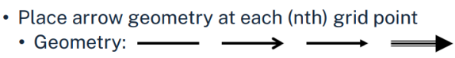Magnitude
* Arrows
  + Length -> Represents magnitude of the vector field
  + In case of very fast changing velocity
    - Better use arrows of constant length -> Indicate magnitude separately (e.g. color coding)
* 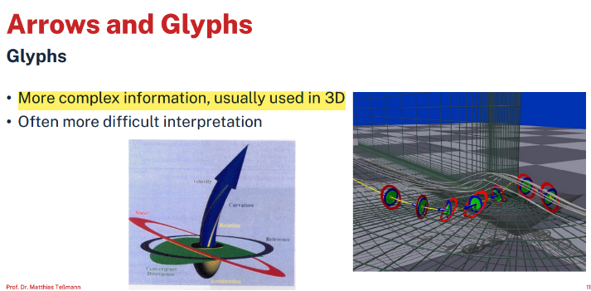Glyphs
  + More complex information, usually used in 3D
* Advantages
  + Simple
  + Absolute value directly visible
  + 2D fields without complex small structures
* Disadvantages
  + Inherent occlusion effects (Occlusion "is the effect of one object in a 3-D space blocking another object from view.")
  + Very small and overlapping arrows
  + Difficult for 3D and time-dependent fields
  + Poor results if magnitude of velocity changes rapidly
    - Use arrows of constant length and color code magnitude

## A diagram of a mathematical equation Description automatically generated5.2 Characteristic Lines in Vector Fields

* Time lines / time surfaces
  + Line/surface of massless elements moving with flow
  + Points of identical time
    - 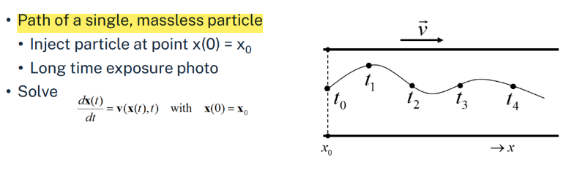Connect particles that were released simultaneously
* Path lines
  + Path of a single, massless particle
* Streak lines
  + 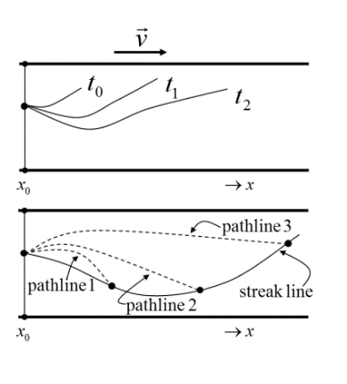No particle path, but velocity direction (on line described by dye)
  + Connecting line of all particles starting within 0 < ti < t0 at x0
* Stream lines (or streamlines)
  + Tangential to the vector field -path lines for each ti
  + Photo with short time exposure of vector field v at ti
    - Freeze the velocity field and compute path lines
    - 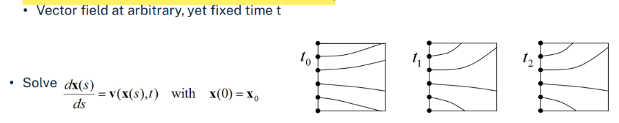Information about whole vector field

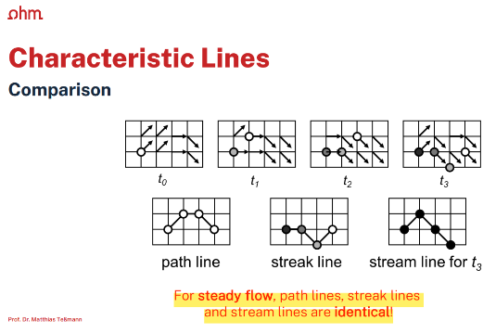

## 5.3 Particle Tracing

* 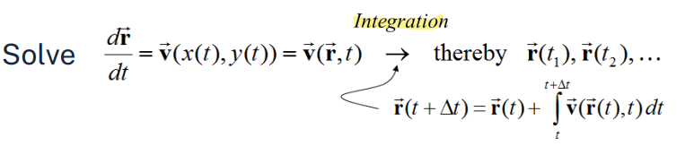Basic idea: trace particles within the field
  + Characteristic lines
* Given
  + Velocity field of particles / fluid
* Task
  + Find the path of one (or many) massless particles in this field
* Integration
  + This requires solving ordinary differential equations (ODE)
    - Usually of first order initial value problems
  + Various methods: • Single step: Euler • Multi step: Adams Bashforth • Multi stage: Runge-Kutta, Heun
* Ordinary differential equation
  + Discretize the "time variable": {t1, t2, ... }
  + Determine rj which approximates the solution r(tj )
  + 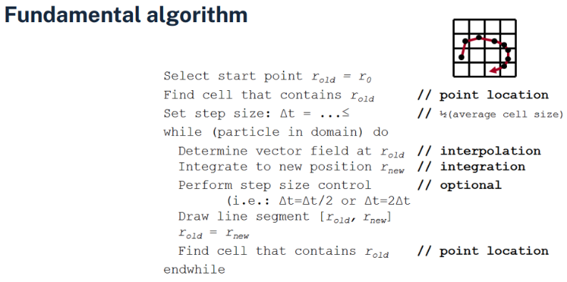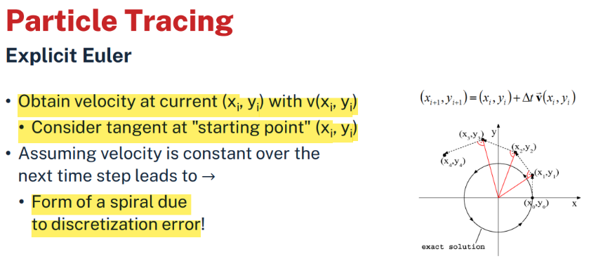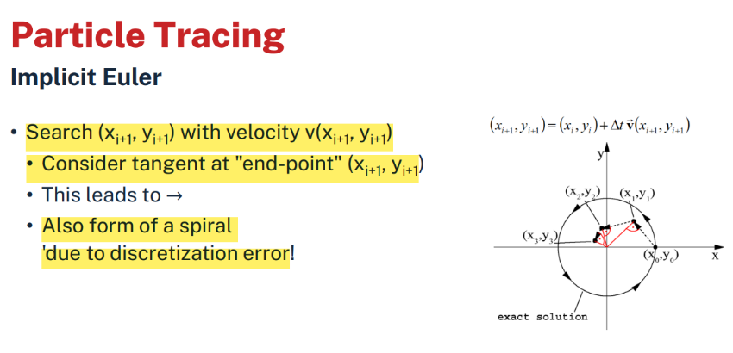Usually, we use constant step size: tj+1 = tj + ∆t

Konstant

* Fundamental algorithm
  + Pick a point (= particle) in the data region
  + Determine its path (= integral curve) emanating at this point
* How to do cell search?
  + Depends on the type of mesh!
  + Global search only at the very beginning
    - 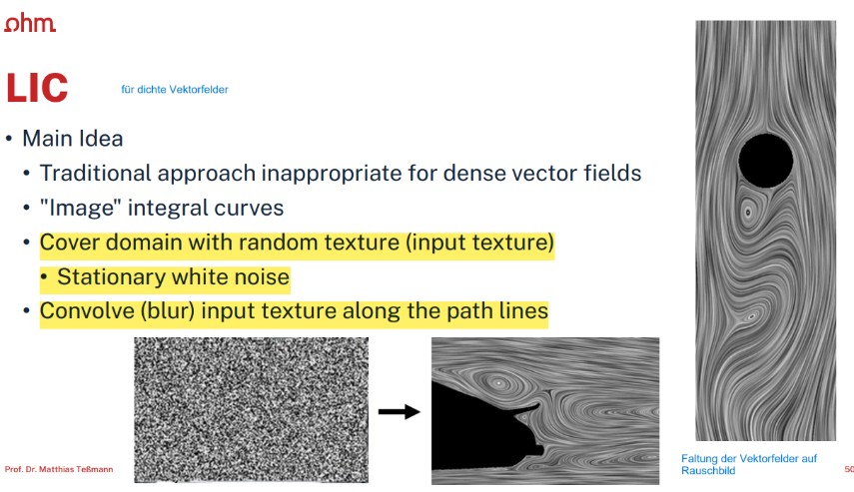Later on, only local search

## 5.4 Line Integral Convolution

* LIC für dichte Vektorfelder
* Main Idea
  + Traditional approach inappropriate for dense vector fields
  + Cover domain with random texture (input texture)
    - zB Stationary white noise
  + Convolve (blur) input texture along the path lines
* 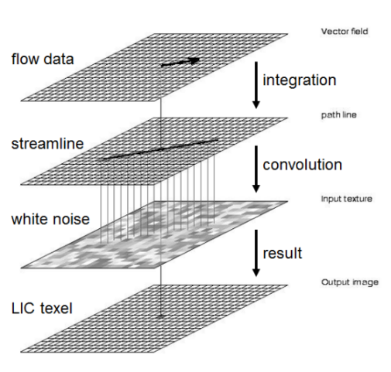Algorithm for 2D LIC
  + 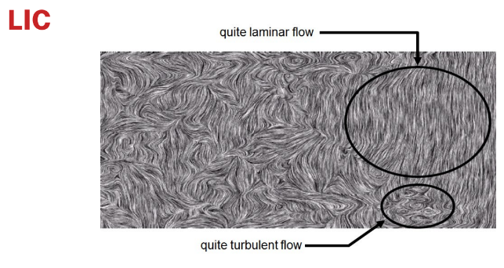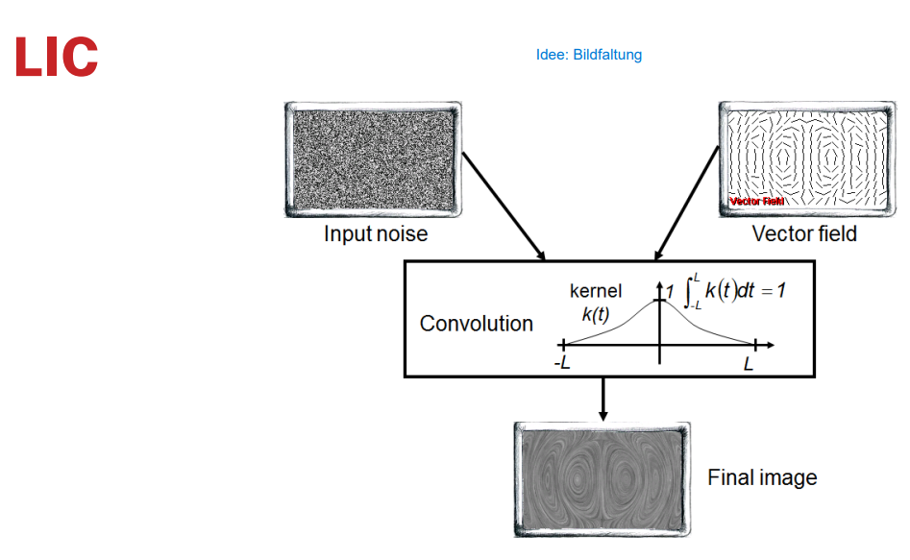Convolve random texture along the streamlines

# A diagram of a tree Description automatically generatedSeveral different types of cubes Description automatically generated6. 3D Scalar Fields

## 6.1 Volume Visualization

* Essential information in the interior
* Cannot be described by geometric representation
  + Fire, clouds, gaseous phenomena

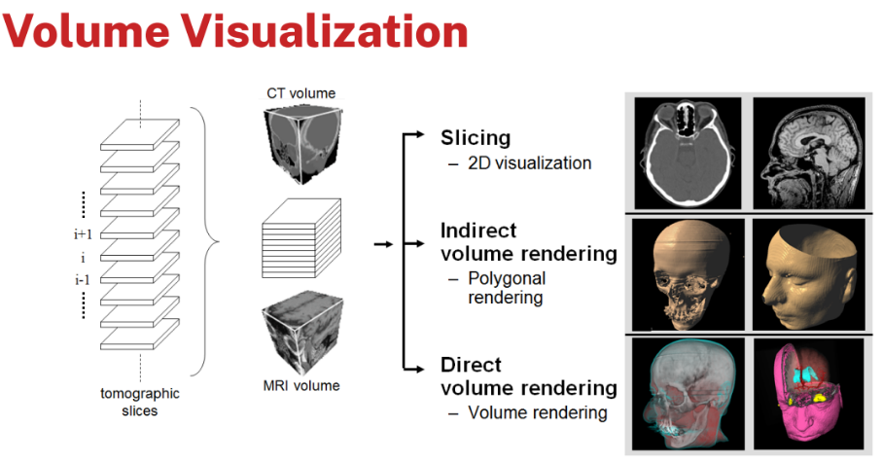

* Main visualization approaches
  + Slicing
    - Standard 2D approach, Techniques for 2D scalar fields
  + Indirect volume rendering
    - Convert/reduce volume data to surface representation -> Stichwort: Isoflächen
  + Direct volume rendering
    - Take volume data as real volumetric object
    - Directly get a 3D representation of the volume data
* Considerations
  + Indirect volume rendering techniques -> Often result in complex representations
  + Direct volume rendering techniques
    - "Global" representation integrating physical characteristics
    - 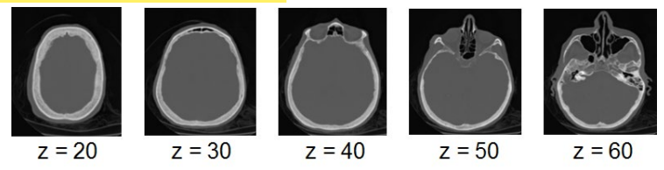Interactive display difficult due to numerical complexity

## 6.2 Slicing of Volume Data

* Orthogonal slicing
  + Resample the volume data on parallel planes perpendicular to the x-, y-or z-axis -> Example: z = -25, -24, ..., 23, 24
  + Let the user interactively change the z-value
  + Use visualization techniques for 2D scalar fields
    - Color coding, isolines, height fields, …
* 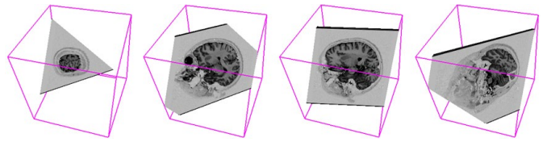Oblique slicing (MPR - multiplanar reformating)
  + Resample volume data on arbitrarily oriented slices
  + Exploit graphics hardware
    - Store volume data in 3D texture memory
    - Get sectional polygon (plane clipped with bounding box of volume)
    - 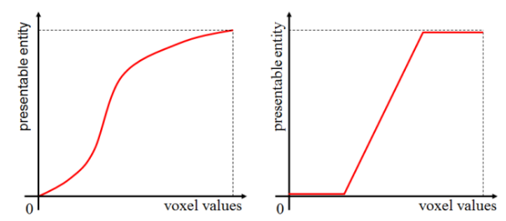Render textured polygon

## 6.3 Classification

* Transfer function
  + Map voxel values to representable entities
    - 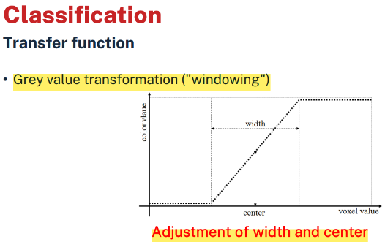Color, intensity, opacity, etc.
* Goals and issues
  + Often interactive manipulation of transfer functions needed
  + Extract important features of the data set

## 6.4 Indirect Volume Rendering

* If f(x,y,z) is differentiable in every point, then the level sets {(x,y,z)|f(x,y,z) = c} are smooth surfaces (denoted iso-surfaces) to the iso-value c
* Techniques to reconstruct isosurfaces
  + Opaque cube (Cuberille method), Dividing cube
  + 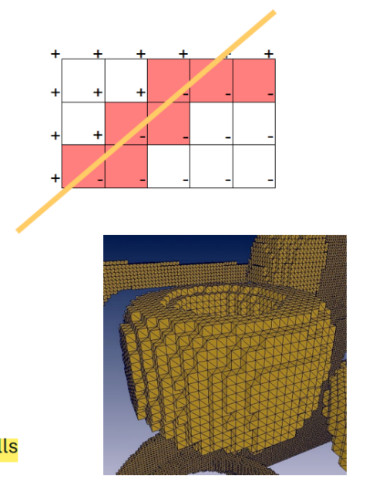Marching cube
  + Marching tetrahedra
* While opaque cube and marching cube methods are restricted to structured grids, the marching tetrahedra method can deal with any kind of mesh

### 6.4.1 Opaque Cubes

* Volume data on regular grid
  + Detect all cells that intersect the iso -surface f = c by checking vertices
  + If fi,j,k > c mark vertex (i,j,k) with +, otherwise with –
  + Find all boundary front -faces
    - Faces where normal points towards viewpoint (N ⋅V > 0) and where normal points outwards the cell
  + Render these faces as shaded polygons
* 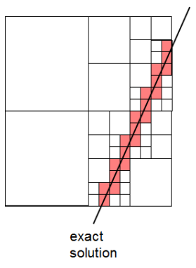"Voxel" point of view: NO interpolation within cells
* Evaluation
  + Method yields blocky surfaces since cell is either opaque or not
  + Improvement through adaptive subdivision
    - Subdivide each marked cube into eight smaller cubes
    - Use trilinear interpolation to determine the function value in the center
    - Repeat the cuberille approach for each new cube until pixel size
    - This is known as "dividing cubes"

## 6.4.2 Marching Cubes

* Better approximation of the "real" iso-surface
  + 3D analog to the isoline construction method (marching squares)
* Strategy
  + Approximates the surface by a triangle mesh
  + Surface found by linear interpolation along cell edges
  + Uses gradients as the normal vectors of the iso-surface
  + Efficient computation by means of lookup tables
* 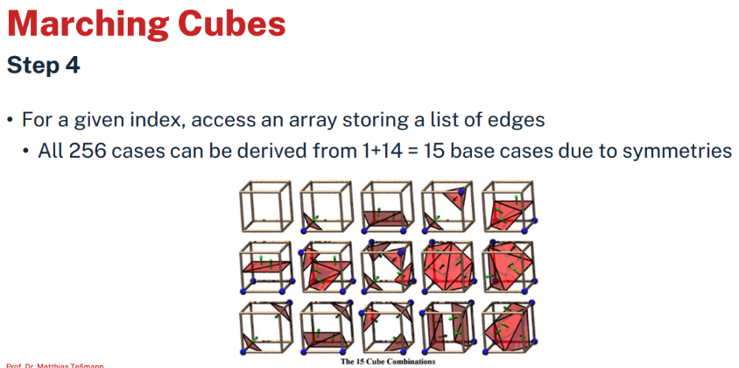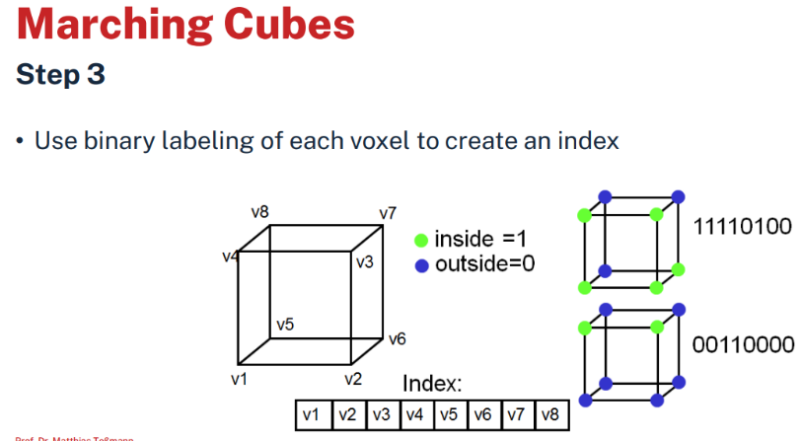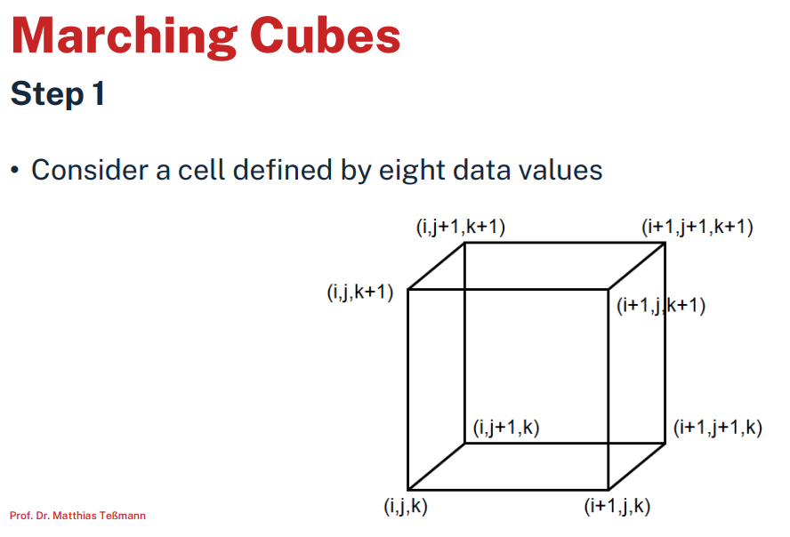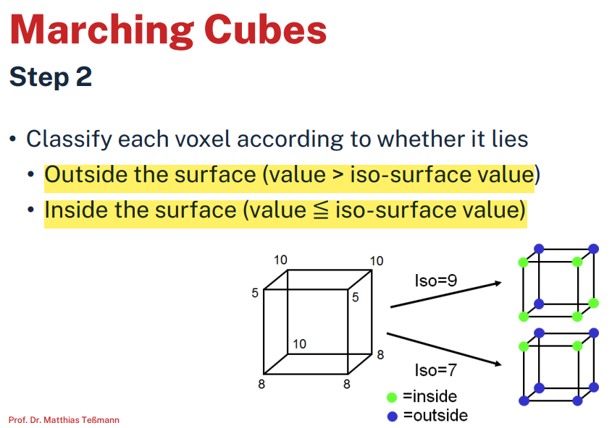The core algorithm
  + Cell consists of 4 (8) pixel (voxel) values
  + Classify each vertex as inside or outside
  + Build an index
  + Get edge list from table[index]
  + Interpolate the edge location
  + Compute gradients
  + Consider ambiguous cases
  + Go to next cell
* Enhancements
  + 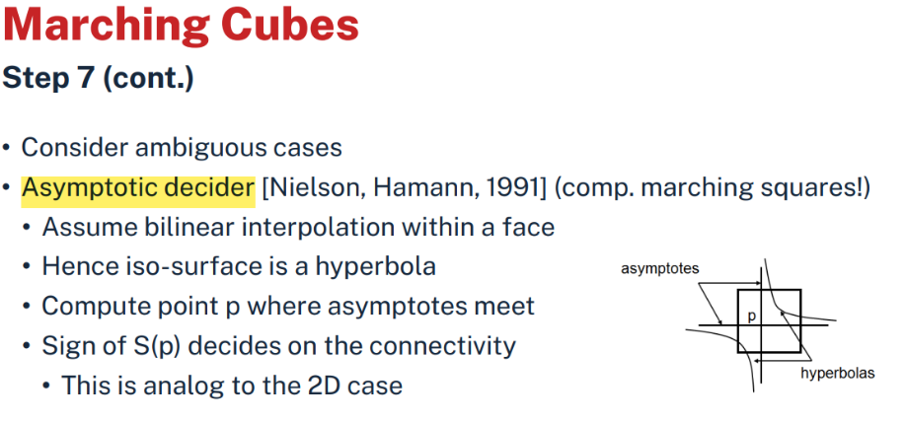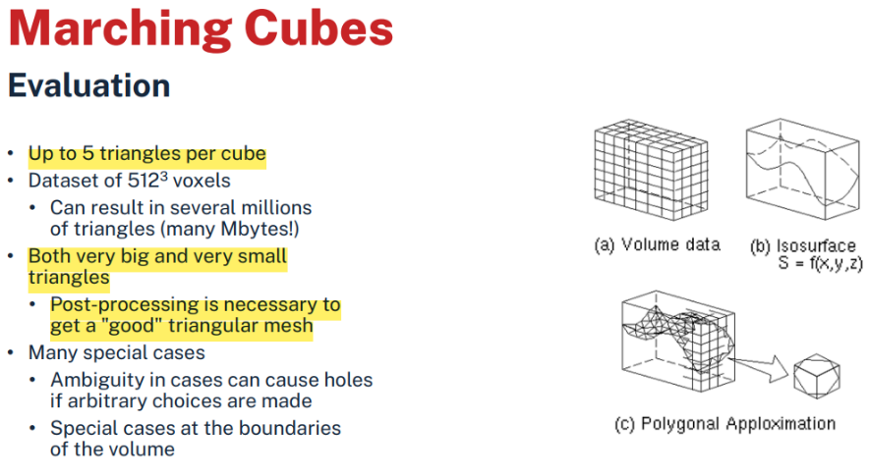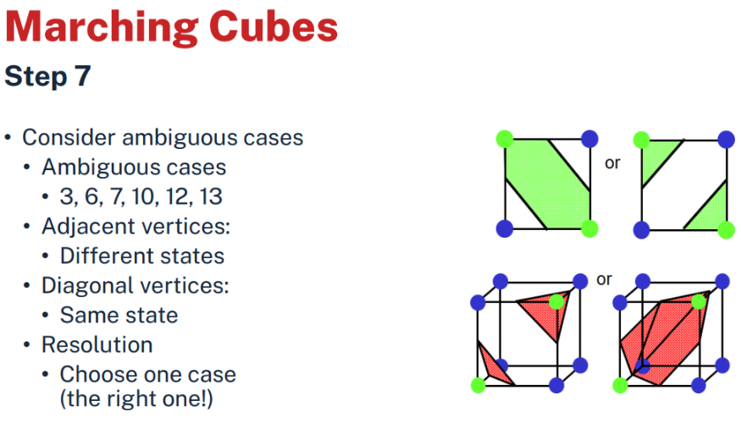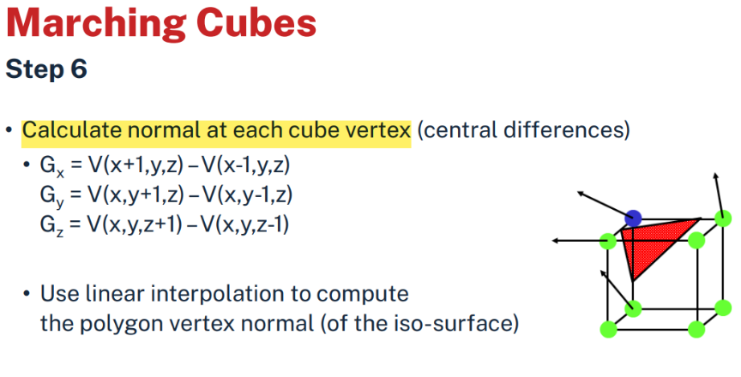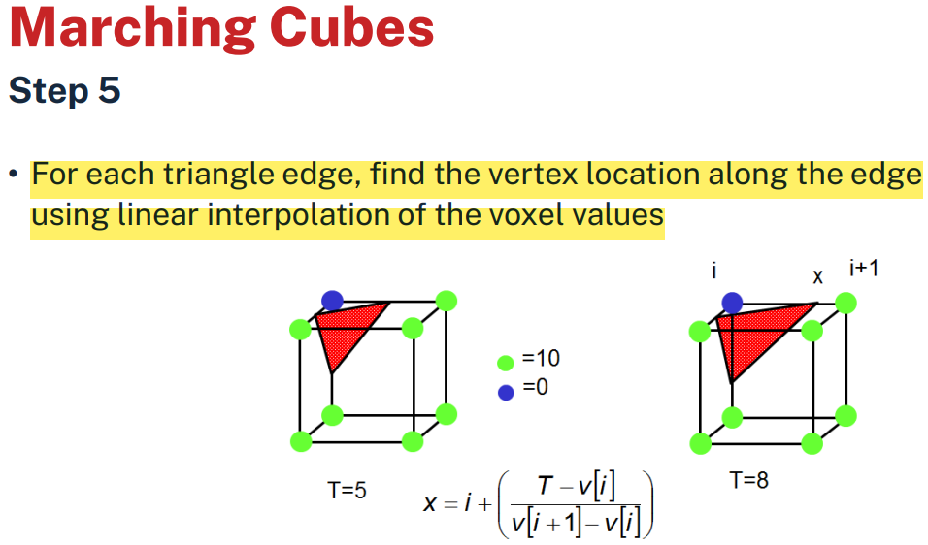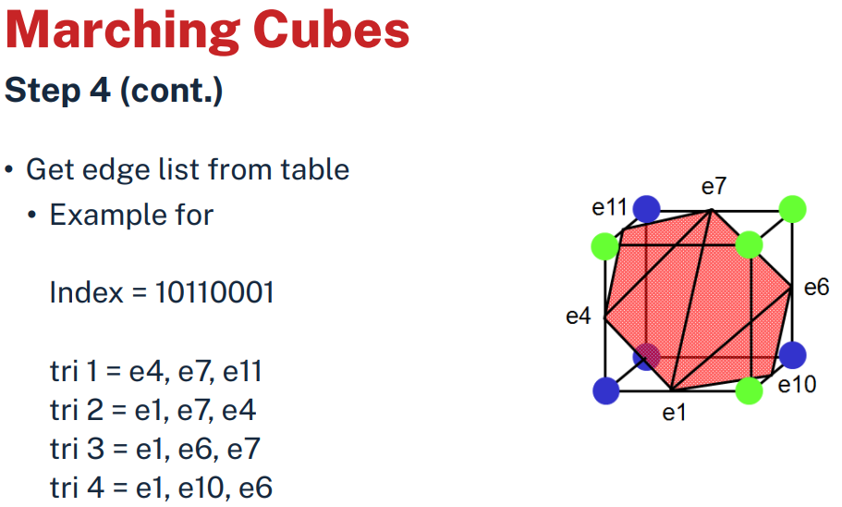Semi-transparent representation (Requires sorting)
  + Optimization
    - Reuse values from prior calculations
    - Prevent vertex replication
    - Mesh simplification
  + Accelerated display
  + High quality display
    - 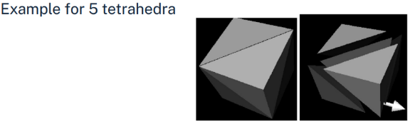Ray-tracing algorithm

### 6.4.3 Marching Tetrahedra

* Alternative to Marching Cubes
* Split each cube into five or six tetrahedra
* Yields more triangles and "rougher" surface than MC
* 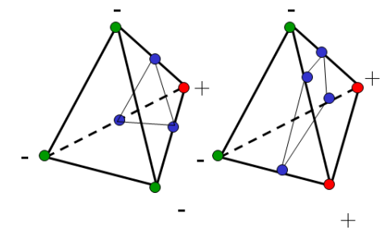Approach
  + Primarily used for unstructured grids
  + Process each cell similarly to the MC-algorithm
    - Mark vertices with + or -, depending on f > c or not
  + Only two possible non-trivial cases for a tetrahedron
    - One "-" and three "+" (or vice versa): Intersection surface is a triangle
    - Two "-" and two "+": Intersection surface is a quadrilateral
      * Split into two triangles using the shorter diagonal
* Properties
  + Fewer cases, i.e. 3 instead of 15
    - Linear interpolation within cells
    - No problems with consistency between neighboring cells
  + Also many triangles of different size
    - Number of generated triangles might increase considerably compared to the MC algorithm due to splitting into tetrahedra
    - Huge amount of geometric primitives
  + But, several improvements exist
    - Hierarchical surface reconstruction
    - View-dependent surface reconstruction
    - Mesh decimation

### A diagram of a prism Description automatically generated6.4.4 Surfaces from Contours

* Approach
  + Find closed contours in successive 2D slices
    - Often semi-automatic procedure with user-interaction!
    - Requires a lot of expertise
  + Represent contours as poly-lines
  + Reconstruction
    - 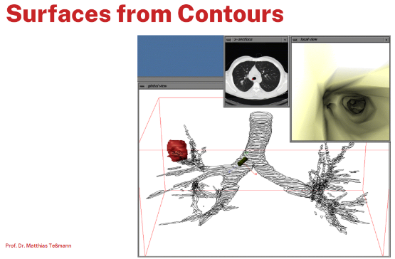Connect contours representing the same object from neighboring slices and form triangles
* Problems
  + Many contours in each slice
  + There is a high variation between slices
    - Correspondence between neighboring slices can be difficult
    - Branching has to be handled (not always easy)

## 6.5 Direct Volume Rendering

* Properties (of direct volume rendering)
  + Directly get a 3D representation of the volume data
  + The data is considered to represent a semi-transparent light-emitting medium
    - Hence, also gaseous phenomena can be simulated
  + Approaches are based on the laws of physics: • Emission • Absorption • Scattering
  + The volume data is used as a whole -> Look inside, see all interior structure
* Advantages
  + Use all information (comprehensive representation)
  + Show fuzzy and amorph objects
  + Segmentation: Visualisieren der Daten -> Segmentation => zuweisen bestimmter Bereiche mit Farben (Werte)
    - Explicit (voxel labeling)
    - Implicit (use color and opacity based on transfer functions)
* Disadvantages
  + Interactivity: Requires special algorithms and special hardware
  + Assignment of color and opacity is difficult
  + Amount of data
    - * Huge amount of interpolations !

### 6.5.1 Volume Rendering Equation

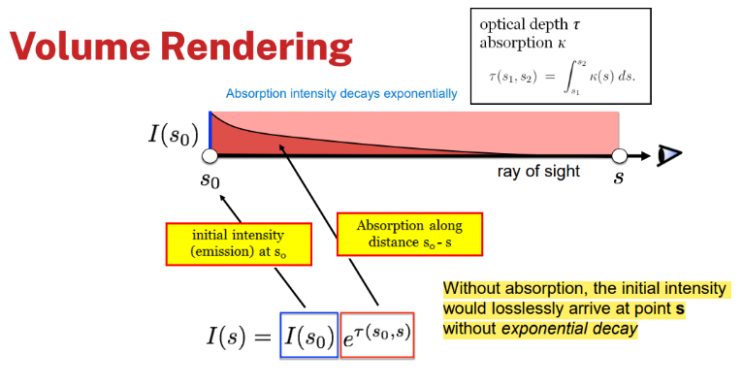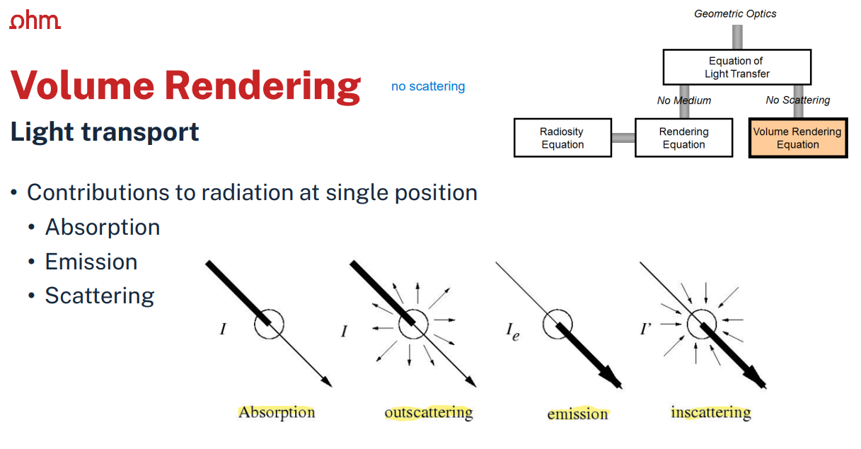

* Emission-absorption model
  + Idea
    - 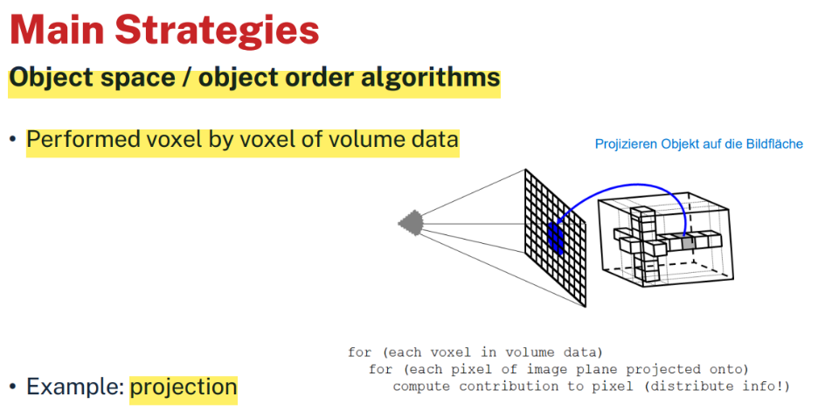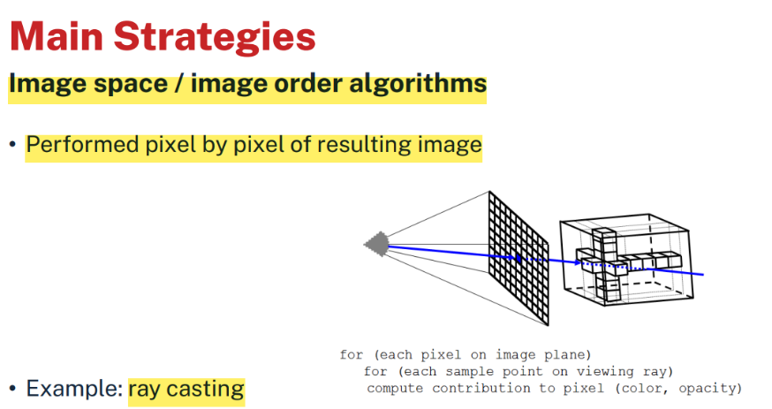Volume filled with light-emitting particles, but also absorpe
    - Particles described by density function

### 6.5.2 Direct Volume Rendering

# A drawing of a cube and a cube with a blue line Description automatically generatedRaycasting

* Characteristics
  + Similar to ray tracing in surface-based graphics
  + In volume rendering, only primary rays are used (speedup)
* Approach
  + Cast a ray into the volume
    - Sampling at certain intervals
  + At each sampling location
    - Interpolation from voxel grid
* Beispiele Folien 433 – 439
* Processing steps
  + Sampling of intensities
  + Assignment of color and opacity
    - Adjustment of transfer functions
  + 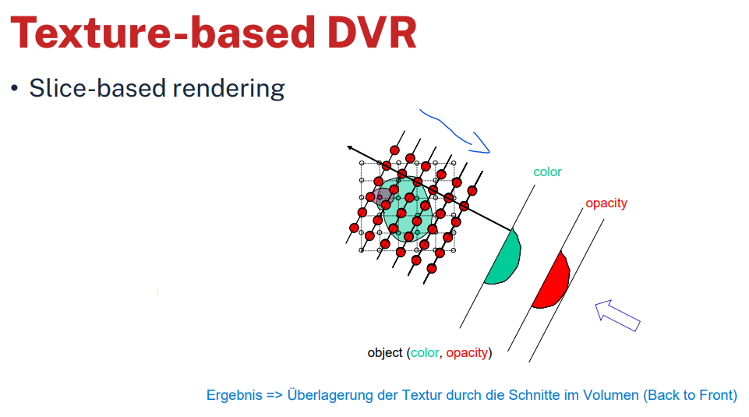Integration

# Texture-based Volume Rendering

* Texture -based DVR (Direct Volume Rendering)
  + Characteristics
    - Object order approach
    - Based on graphics hardware
    - 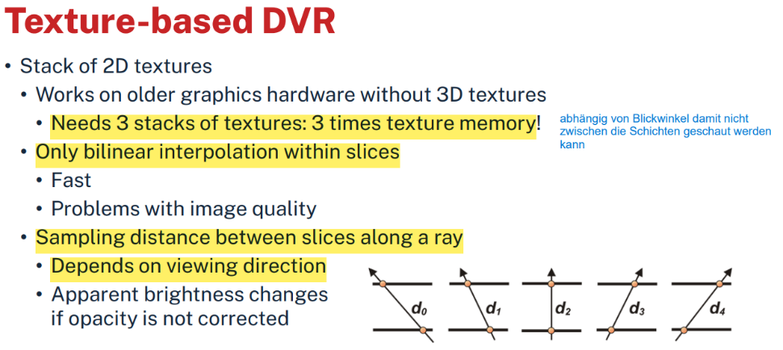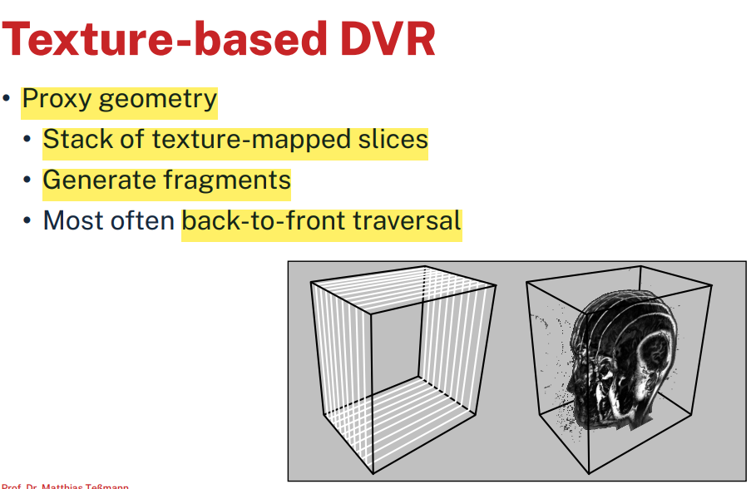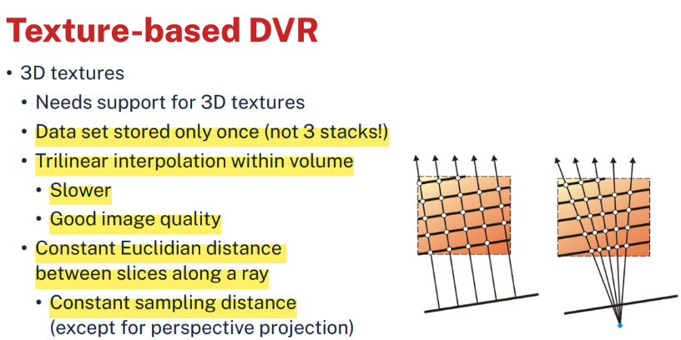Use proxy geometry
  + Artifacts when stack is viewed close to 45 degrees
    - Locations of sampling points may change abruptly
  + 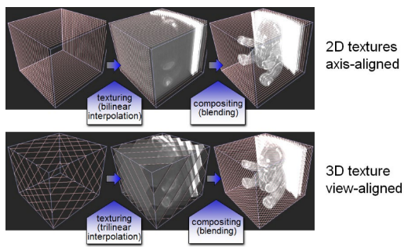3D textured slices
    - View-aligned slices
    - Trilinear interpolation
  + Advantages
    - Exploits graphics hardware
    - Fast for moderately sized data sets
    - Combines surface and volumetric representations
      * Allows for mixture with opaque geometries
  + Disadvantages
    - Limited by texture memory
    - Brute force representation by slices
    - No acceleration techniques as for ray casting
    - 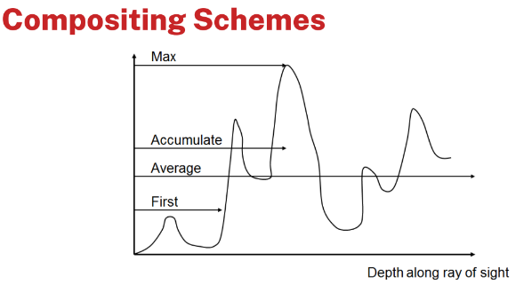Rasterization speed and memory access can be problematic

### 6.5.3 (Other) Compositing Schemes

* 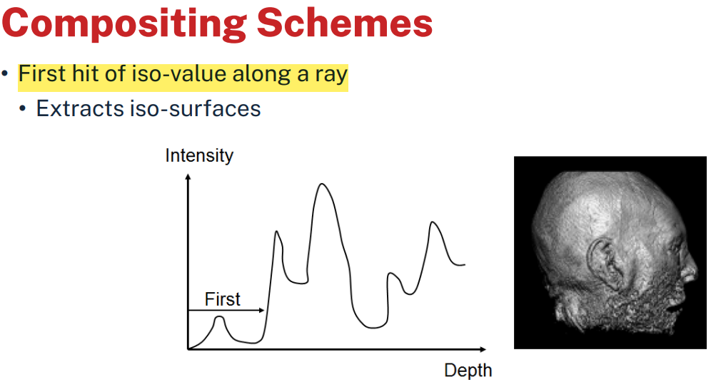Other approaches for determining the final color exist
* 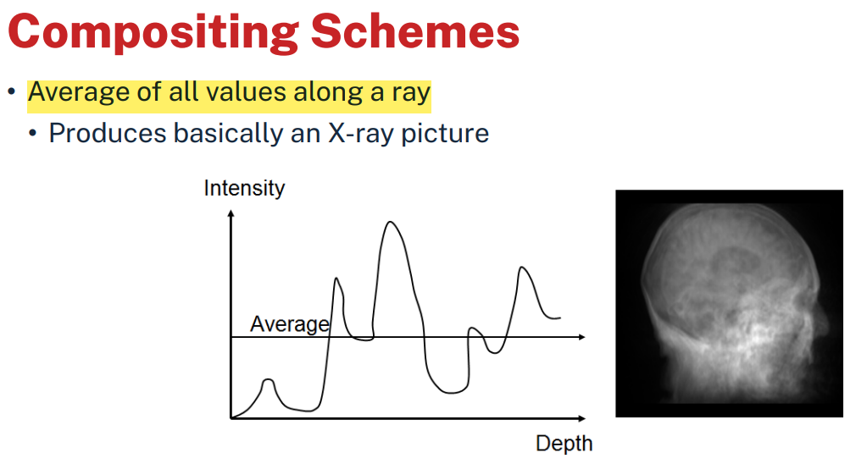Variations of composition schemes: • First • Average • Maximum intensity projection • Accumulate (i.e. evaluation of the integral, chapter 6.5.2)

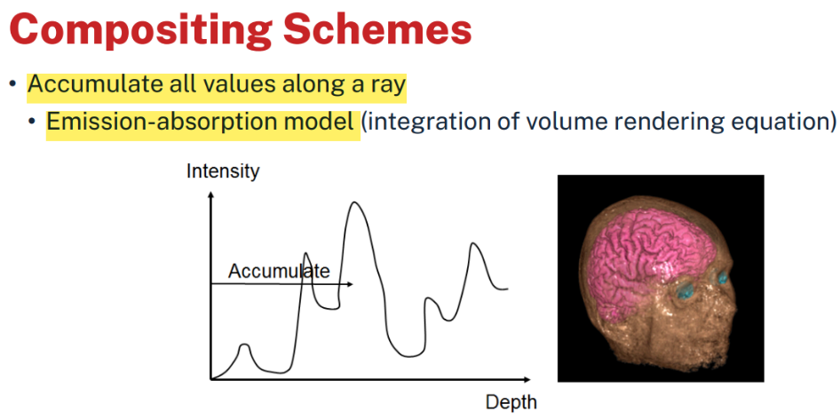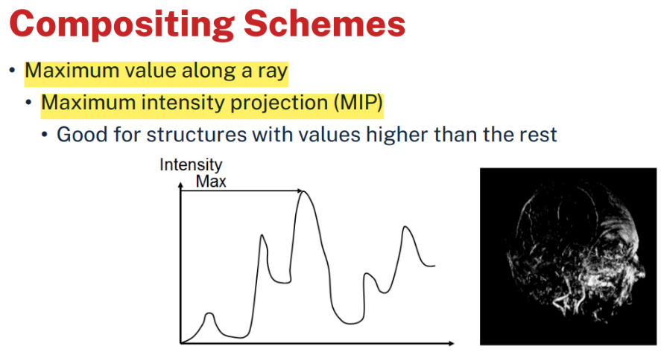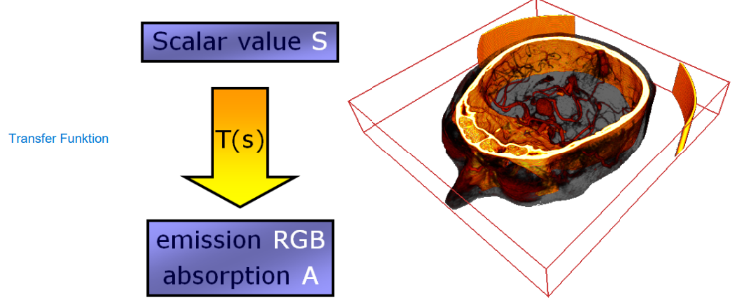

* Def: Wie werden Werte gesetzt dass es richtig Visualisiert wird
  + Bsp: Scalar value => Transfer function => emission RGB, absorption A
* Transfer functions
  + 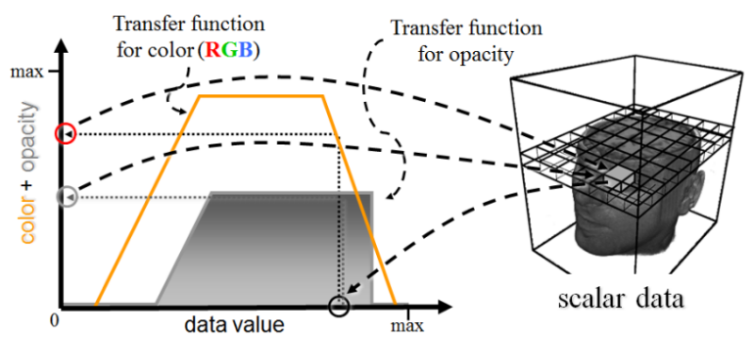Map data value to color and opacity -> look up Wert von Farbe/Grauwert für Scalar data

### 6.5.4 Classification

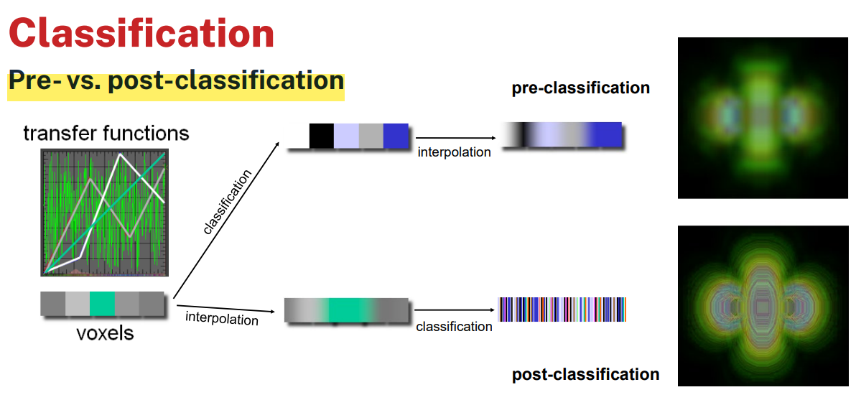

* Isovalue contour surfaces
  + Render opaquely all voxels with values > threshold
    - Unable to display multiple concentric surfaces
  + Use a window instead of a threshold
  + Considerations
    - Usually not only interested in a particular iso-surface but in regions of "change"
  + Feature extraction
    - High value of opacity in regions of change
    - Homogenous regions less interesting -transparent
  + Gradient of the scalar field is taken into account

# Segmentation

* zu meinem Datensatz noch Datensätze die Angeben wo andere Informationen sind (Color, Structure, ...)
* Explicit separation of structures
  + Label voxels indicating a type
  + Note the difference
    - Implicit segmentation ⟷ classification with color and opacity
    - 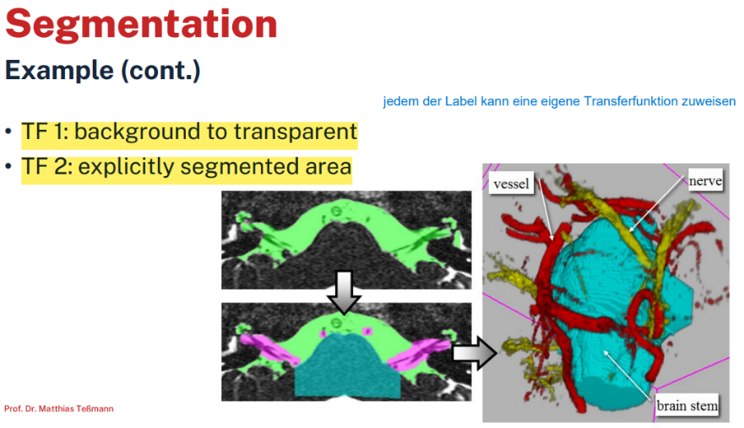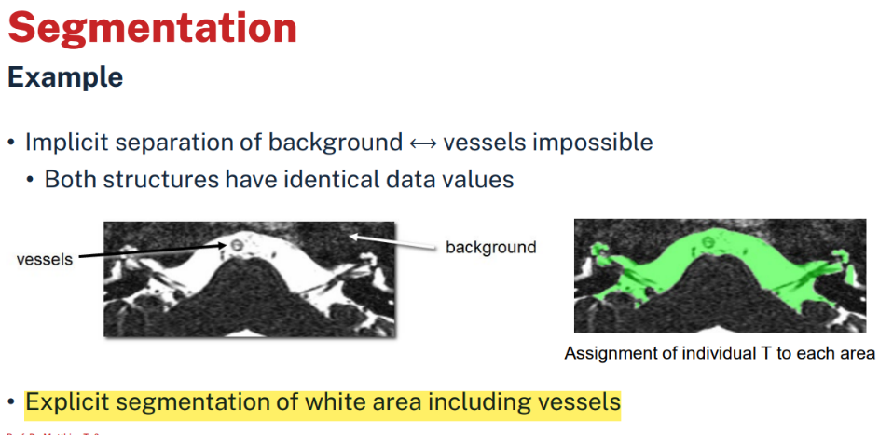Explicit segmentation ⟷ labeling of structures

# Volumetric Shading

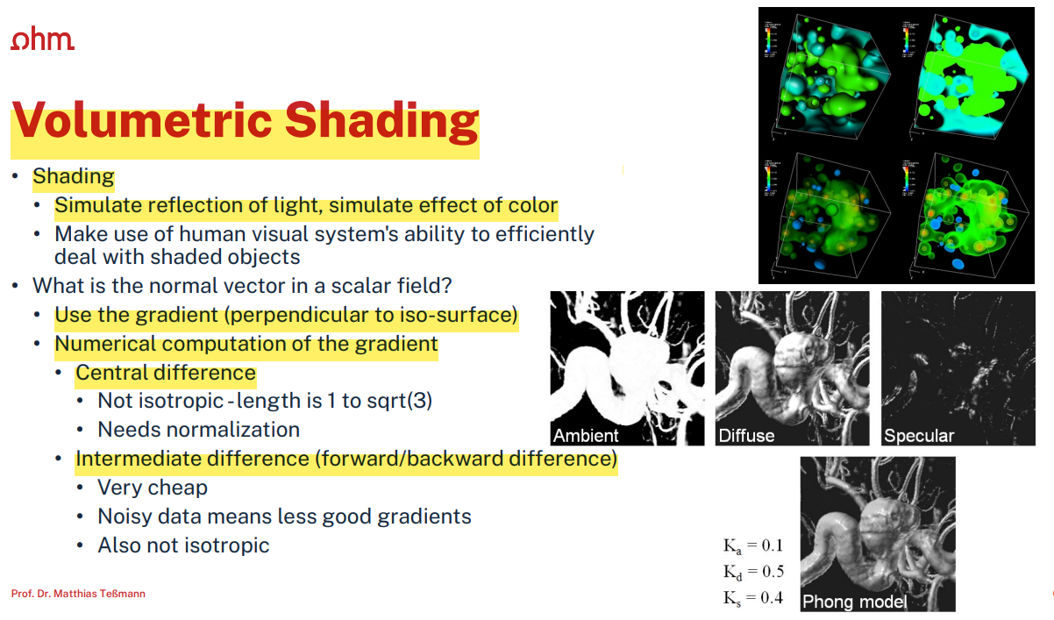

# Outlook

* Physically based rendering
  + Photorealistic rendering based on physically correct lighting calculations (Light transport equation)
  + Can be extended to include volumetric scattering
  + Cannot be evaluated analytically (except for the most simplest scenes)
  + 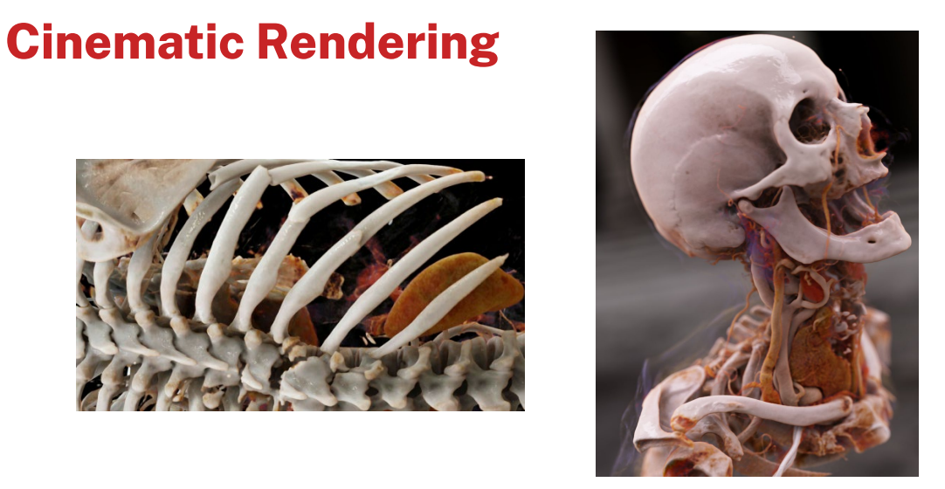Requires many samples to yield a good estimate